SMART FASHION RECOMMENDER APPLICATION

## A PROJECT REPORT

***Submitted by***

|  |  |
| --- | --- |
| **SALAM LEMBA LUWANG** | **960519104071** |
| **SAHADEVAN R** | **960519104068** |
| **SUJITHKUMAR** | **960519104086** |
| **RAJU V P** | **960519104064** |

CONTENTS

### INTRODUCTION

* 1. Project Overview
  2. Purpose

### LITERATURE SURVEY

* 1. Existing problem
  2. References
  3. Problem Statement Definition

### IDEATION & PROPOSED SOLUTION

* 1. Empathy Map Canvas
  2. Ideation & Brainstorming
  3. Proposed Solution
  4. Problem Solution fit

### REQUIREMENT ANALYSIS

* 1. Functional requirement
  2. Non-Functional requirements

### PROJECT DESIGN

* 1. Data Flow Diagrams
  2. Solution & Technical Architecture
  3. User Stories

### PROJECT PLANNING & SCHEDULING

* 1. Sprint Planning & Estimation
  2. Sprint Delivery Schedule
  3. Reports from JIRA

1. **CODING & SOLUTIONING** (Explain the features added in the project along with code)
   1. Feature 1
   2. Feature 2
   3. Database Schema (if Applicable)

### TESTING

* 1. Test Cases
  2. User Acceptance Testing

### RESULTS

* 1. Performance Metrics

### ADVANTAGES & DISADVANTAGES

1. **CONCLUSION**

### FUTURE SCOPE

1. **APPENDIX**

Source Code

GitHub & Project Demo Link

# INTRODUCTION

## Project Overview

We live in a world powered by AI, where all human activities are simplified with machinery. The AI takes control of almost any area. In this project, we included one such powerful tool, a chatbot, that helps recommend goods to customers. The proposed project is about building a fashion website and integrate a chatbot that picks up fashion goods for the users with less time. Instead of checking out so many products and spending lot of time on the internet before buying stuff to fill your wardrobe, get the help of our fashion recommender by simply listing out your preferences. The chatbot is built in such a way that it collects user's likes and dislike by asking them a few questions, pick up the best matches from warehouse and piles up their window with products that they cannot reject. All the products it picks up will never fail to convince the in terms of price, quality and fashion.

## Purpose

The primary motive of the proposed system is to recommend fashion products through recommendations. Online shopping makes one to spend less time on buying products as it does not take time to commute, choose shops, check for the quality of the product, and stand in queues to bill them. Users can save money because of better deals and cheaper price. Money transactions are simpler in online shopping. It brings goods at users’ door step. Since the proposed project comes with a chatbot, it has an added advantage of picking up fashion goods faster. The built-in chatbot assists customers to make a better and a quick decision to purchase a product as it recommends stuff based on user preferences. Through this, the vendor knows what is desired by their customers and knows their expectations so that they can increase sales.

# LITERATURE SURVEY

## Existing problem

While doing online shopping, people are checking out various products. In fact, the number of products they are checking out is very much greater than number of products they are purchasing. Customers have to go through every product to discover the one best thing that satisfies their desire. It automatically takes a long time and can result in the purchase of a product that was not intended for purchase. Sometimes, just to advantage of free shopping customers end up shopping more than they need.

## References

* + 1. A Review of Modern Fashion Recommender Systems
    2. Fashion Recommendation System
    3. Product Recommender Chatbot
    4. Image-based fashion recommender systems
    5. A Survey on Conversational Recommender Systems

## Problem Statement Definition

To come up with a new innovative solution through which user can directly do online shopping based on their choice without any search. It can be done by using the chatbot. It recommends fashion based on user desire.

**Table 2.3.1: Problem Statements**

|  |  |  |  |  |  |
| --- | --- | --- | --- | --- | --- |
| **Problem Statement**  **(PS)** | **I am (Customer)** | **I’m trying to** | **But** | **Because** | **Which makes me feel** |
| PS-1 | Common man | Buy clothes at cheap rate | Buying cheaper clothes at shops near meraises quality issues. | At cheaper rate, unrecognized brandproducts are sold | Disappointed |
| PS-2 | Fashionista | Buy trendy and branded clothes | Availability of desired products is notassured. | The clothes are notup to my expectations | Frustrated |
| PS-3 | Celebrity | Buy clothes like normal people | Due to paparazzi, I cannot do so. | Being a celebrity, people are curiousabout my personal  life | My privacy is invaded |
| PS-4 | Fashion Stylist | Informed about the latest fashion trends | I am not getting apt recommendations from websites. | Sometimes the collections are poorand sometimes the price is high | Upset |

# IDEATION & PROPOSED SOLUTION

## Empathy Map Canvas

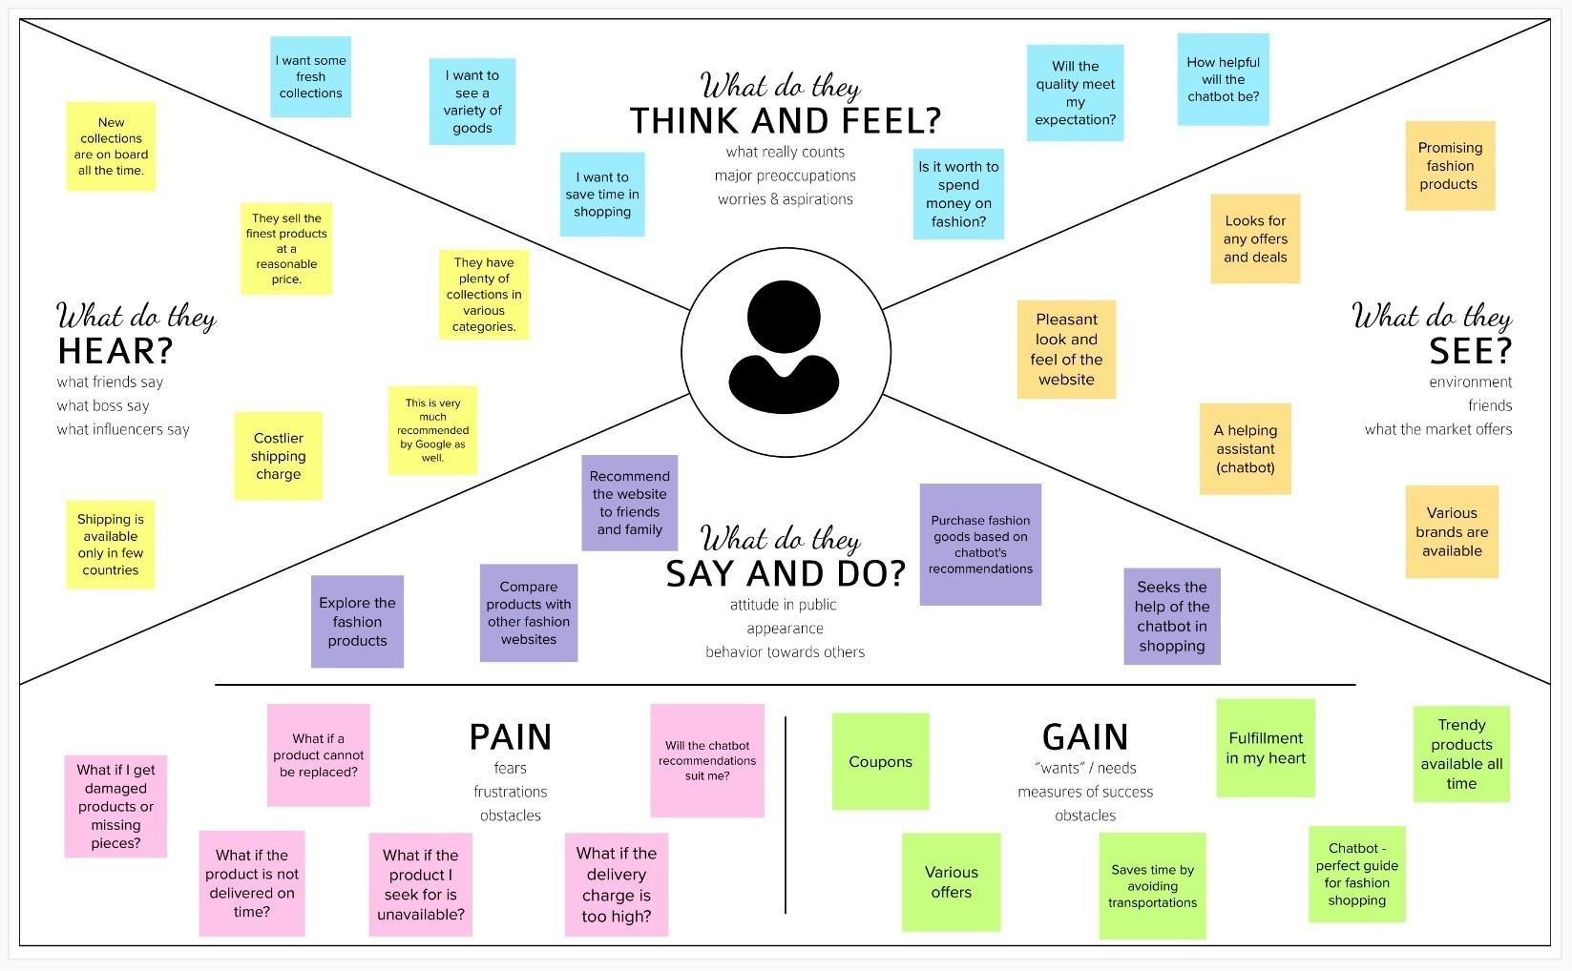

**Figure 3.1.1: Empathy Map Canvas**

## Ideation & Brainstorming

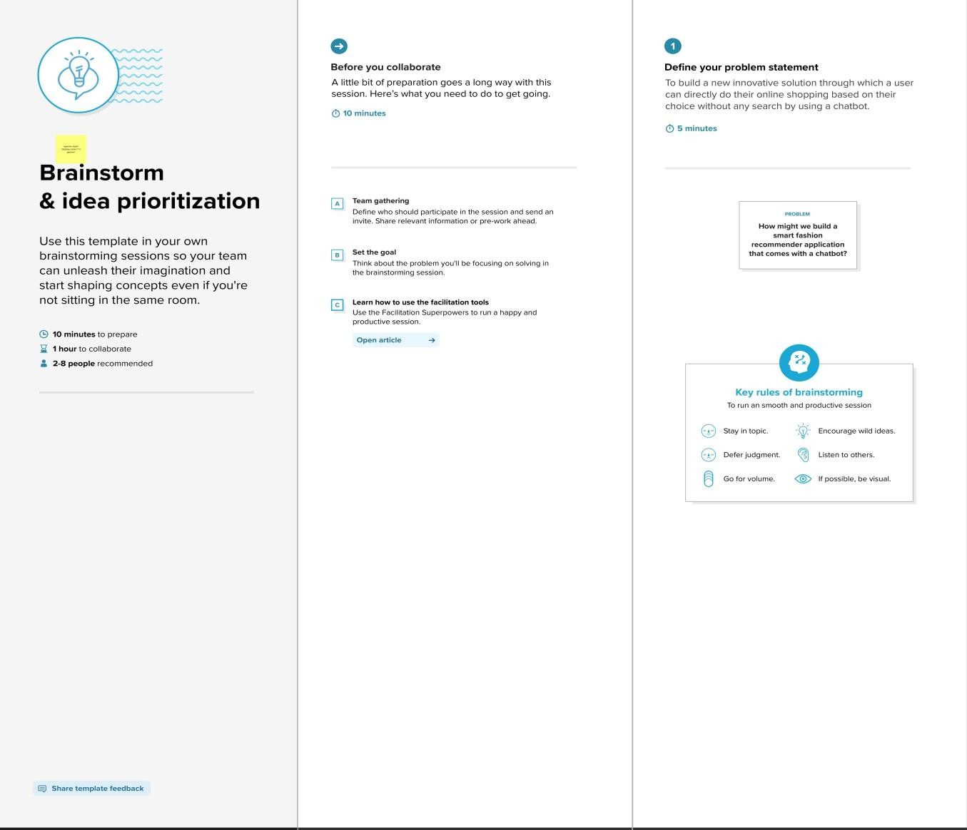

**Figure 3.2.1: Brainstorming & Idea Prioritization**

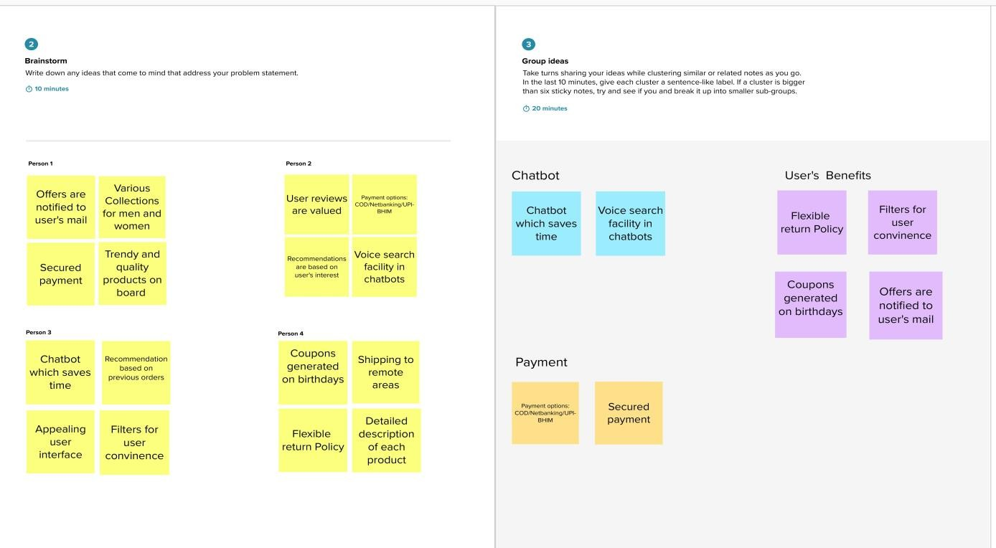

**Figure 3.2.2: Brainstorming & Idea Prioritization**

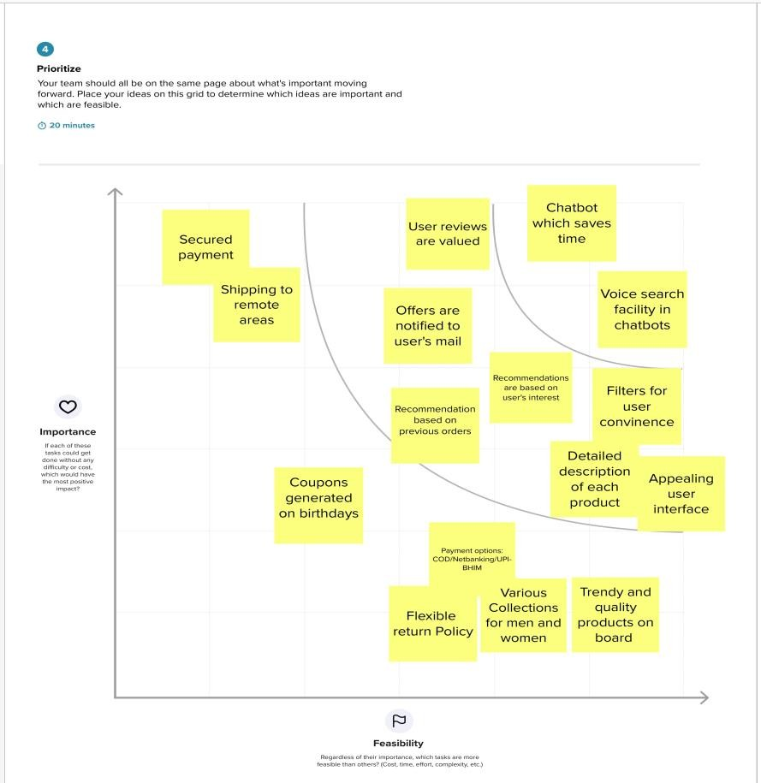

**Figure 3.2.3: Brainstorming & Idea Prioritization**

## Proposed Solution

**Table 3.3.1: Proposed Solution**

|  |  |  |
| --- | --- | --- |
| **S.No.** | **Parameter** | **Description** |
| 1 | Problem Statement (Problem to be solved) | To recommend fashion products based on customer’s choice without any search on a fashion website. |
| 2 | Idea / Solution description | To build a new innovative solution through which a user can directly make their online purchases based on their choice, without any search using a chatbot. |
| 3 | Novelty / Uniqueness | Searching or filtering of products can bedone with ease using chatbot. |
| 4 | Social Impact / Customer Satisfaction | Customers can get their products easily through chatbot without not being redirected to multiple pages. |
| 5 | Business Model (Revenue Model) | Shipping charges, and advertisement. |
| 6 | Scalability of the Solution | More number of users can be managed effectively, since entire application is hosted on cloud. |

## Problem Solution Fit

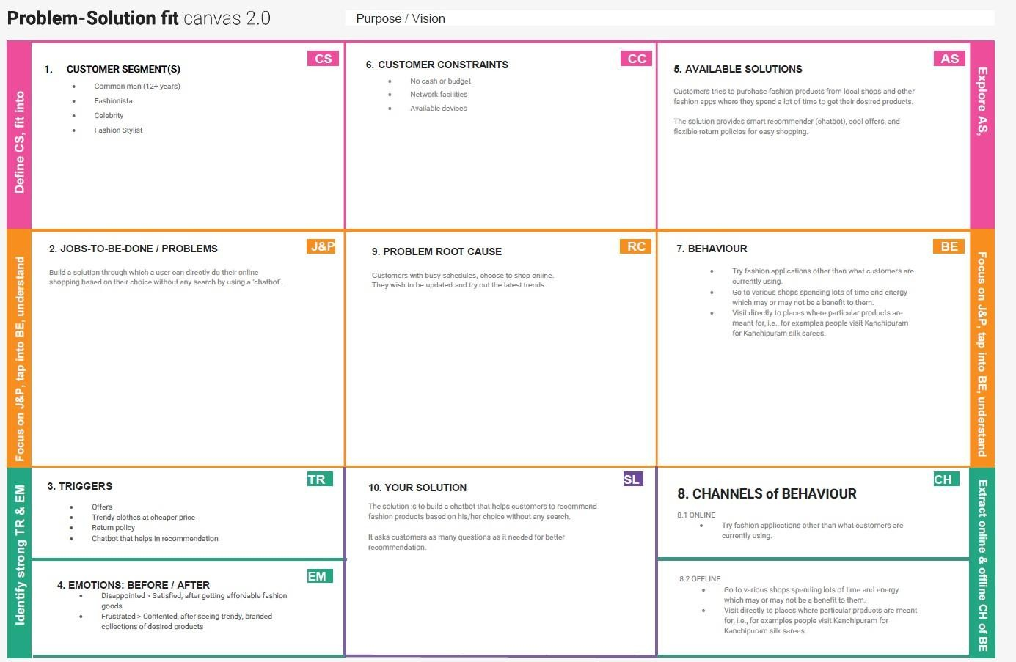

**Figure 3.4.1: Problem Solution Fit**

# REQUIREMENT ANALYSIS

## Functional requirement

**Table 4.1.1: Functional Requirements**

|  |  |  |
| --- | --- | --- |
| **FR No.** | **Functional Requirement (Epic)** | **Sub Requirement (Story/ Sub-Task)** |
| FR-1 | User Registration | Registration through Form. |
| FR-2 | User Confirmation | Confirmation via Email. |
| FR-3 | User Search | Through search box and chatbot. |
| FR-4 | User payment | Through UPI/Net banking/COD. |
| FR-5 | Chatbot recommendation | Recommends products according to user  commands. |

## Non-Functional requirement

**Table 4.1.2: Non-Functional Requirements**

|  |  |  |
| --- | --- | --- |
| **FR No.** | **Non-Functional Requirement** | **Description** |
| NFR-1 | Usability | User friendly interface that makes them easy to  access. |
| NFR-2 | Security | Data will not be misused by any third party  applications. |
| NFR-3 | Reliability | Resetting password if user is unable to login (forget  password option) |
| NFR-4 | Performance | Chatbot for apt recommendation and quicker  search. |
| NFR-5 | Availability | New collections are available according to the  trend. |
| NFR-6 | Scalability | More number of users can be managed effectively,  since entire application is hosted on cloud. |

# PROJECT DESIGN

## Data Flow Diagram

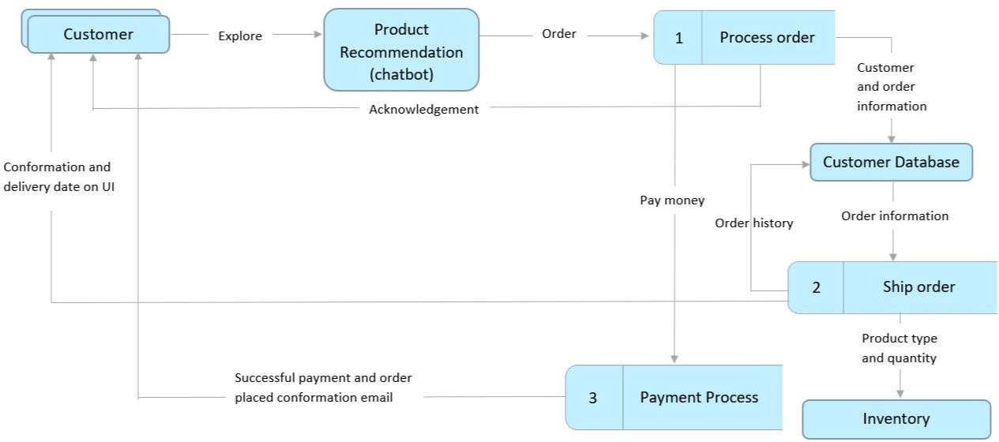

**Figure 5.1.1: Data Flow Diagram**

## Solution & Technical Architecture

**Solution Architecture**

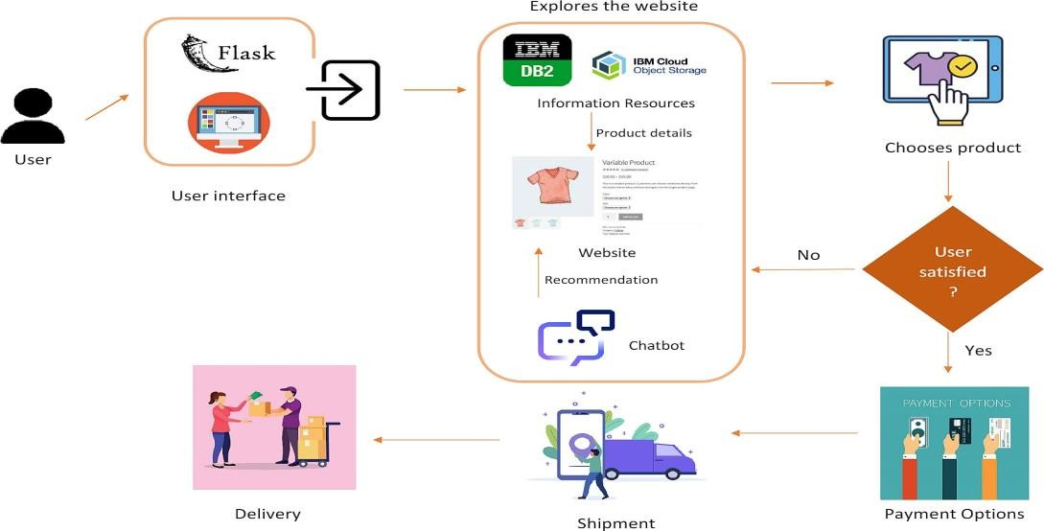

**Figure 5.2.1: Solution Architecture**

### Technical Architecture

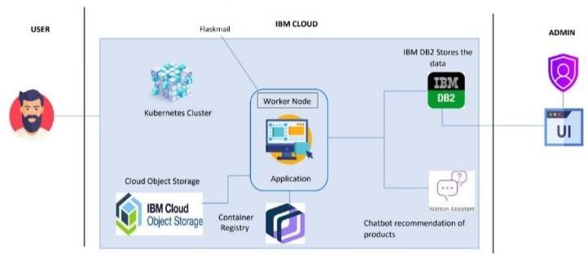

**Figure 5.2.2: Technical Architecture**

## User Stories

**Table 5.3.1: User Stories**

|  |  |  |  |  |  |  |
| --- | --- | --- | --- | --- | --- | --- |
| **User Type** | **Functional**  **Requireme nt (Epic)** | **User story Number** | **User Story / Task** | **Acceptance Criteria** | **Priority** | **Release** |
| Customer (Web user) | Registration | USN-1 | As a user, I can register for the application by entering my email, password, and confirming my  password. | I can access my account or redirect to the next process. | High | Sprint-1 |
|  |  | USN-2 | As a user, Iwill receive a confirmation email, once I have registered for the  application. | I can receive confirmation email & click confirm | High | Sprint-1 |
|  | Login | USN-3 | As a user, I can log into the application by entering email &  password | I can be redirected to the dashboard. | High | Sprint-1 |

|  |  |  |  |  |  |  |
| --- | --- | --- | --- | --- | --- | --- |
|  | Dashboard | USN-4 | As a user, I can  explore the products on the site. | I can ask  recommendations from the chatbot. | High | Sprint-1 |
|  |  |  |  | I can view the  offers and deals. |  |  |
|  | Chatbot | USN-5 | As a user, I can find my desired products through  recommendation. | I can save my time in exploring the products. | High | Sprint-2 |
|  | Wish list | USN-6 | As a user, I can add  the products to my wish list. | I can save  products for future reference. | Medium | Sprint-2 |
|  | Payment | USN-7 | As a user, I can make payment. | I will receive mail  after successful payment. | High | Sprint-3 |
|  | Payment Confirmation | USN-8 | As a user, I will  receive a confirmation email. | I can be assured  of secured payment. | High | Sprint-3 |
|  | Coupon Generation | USN-9 | As a user, I will be provided with customized coupons on my  birthday. | I will be contented and saving money on my special day. | Low | Sprint-4 |
|  | Shipping | USN-10 | As a user, I will be able to view the estimated time of  delivery. | I can track my orders. | Medium | Sprint-4 |
| Administrator | Login | USN-11 | As an admin, I can register for the application by entering my email, password, and confirming my  password. | I can track users’ purchases. | High | Sprint-4 |
|  |  |  |  | I can check the  database of the stock. |  |  |

# PROJECT PLANNING & SCHEDULING

## Sprint Planning & Estimation

**Table 6.1.1: Sprint Planning & Estimation**

|  |  |  |  |  |  |  |
| --- | --- | --- | --- | --- | --- | --- |
| **Sprint** | **Functional Requirement (Epic)** | **User Story Number** | **User Story / Task** | **Story Points** | **Priority** | **Team Members** |
| Sprint-1 | Registration | USN-1 | As a user, I can register for the application by entering my email, password, and confirming my  password. | 2 | High | Salam Lemba Luwang |
| Sprint-1 |  | USN-2 | As a user, I will receive confirmation email once I have registered for the  application | 3 | High | Sahadevan |
| Sprint-1 | Login (User) | USN-3 | As a user, I can log into the application by entering email and password | 2 | High | Raju V P |
| Sprint-1 | Dashboard | USN-4 | As a user, I can explore the products on the site. | 5 | High | Sujithkumar G |
|  |  | USN-5 | As a user, I can view offers. | 3 | Medium | Raju VP |
| Sprint-2 | Chatbot | USN-6 | As a user, I can find my desired products through recommendation. | 8 | High | Sahadeavan & Sujithkumar |
| ujithkumar |  | USN-7 | As a user, I can ask queries and get clarified. | 5 | High | Salam Lemba Luwang,Raju V P |

|  |  |  |  |  |  |  |
| --- | --- | --- | --- | --- | --- | --- |
|  |  | USN-8 | As a user, I can get suggestion on color combinations. | 2 | Medium | Sahadeavn |
| Sprint-3 | Wish-list | USN-9 | As a user, I can add the products to my wish list. | 2 | Medium | Sujithkumar |
| Sprint-3 | Payment | USN-10 | As a user, I can make payment. | 8 | High | Salam Lemba Luwang |
| Sprint-3 | Order confirmation | USN-11 | As a user, I will receive a confirmation email. | 5 | High | Sujithkumar,V P raju |
| Sprint-4 | Coupon generation | USN-12 | As a user, I will be provided with customized coupons  on my birthday. | 8 | Low | Sahadevan |
| Sprint-4 | Shipping | USN-13 | As a user, I will be able to view the estimated time of  delivery. | 3 | Medium | V P Raju |
| Sprint-4 | Login (Administrator) | USN-14 | As an admin, I can register for the application by entering my email, password, and confirming my password. | 2 | High | Salam Lemba luwng |
|  |  | USN-15 | As an admin, I can check out the database about the stock and have a track of all the things that the users are purchasing. | 2 | Medium | Sahadevan |

## Sprint Delivery Schedule

**Table 6.2.1: Sprint Delivery Schedule**

|  |  |  |  |  |  |  |
| --- | --- | --- | --- | --- | --- | --- |
| **Sprint** | **Total Story Points** | **Durati on** | **Sprint Start Date** | **Sprint End Date (Planned)** | **Story Points Completed**  **(as on Planned**  **End Date)** | **Sprint Release Date (Actual)** |
| Sprint-1 | 15 | 6 Days | 24 Oct 2022 | 29 Oct 2022 | 29 Oct 2022 | 29 Oct 2022 |
| Sprint-2 | 15 | 6 Days | 31 Oct 2022 | 05 Nov 2022 | 06 Nov 2022 | 05 Nov 2022 |
| Sprint-3 | 15 | 6 Days | 07 Nov 2022 | 12 Nov 2022 | 12 Nov 2022 | 12 Nov 2022 |
| Sprint-4 | 15 | 6 Days | 14 Nov 2022 | 19 Nov 2022 | 19 Nov 22 | 19 Nov 2022 |

## Reports from JIRA

### Roadmap

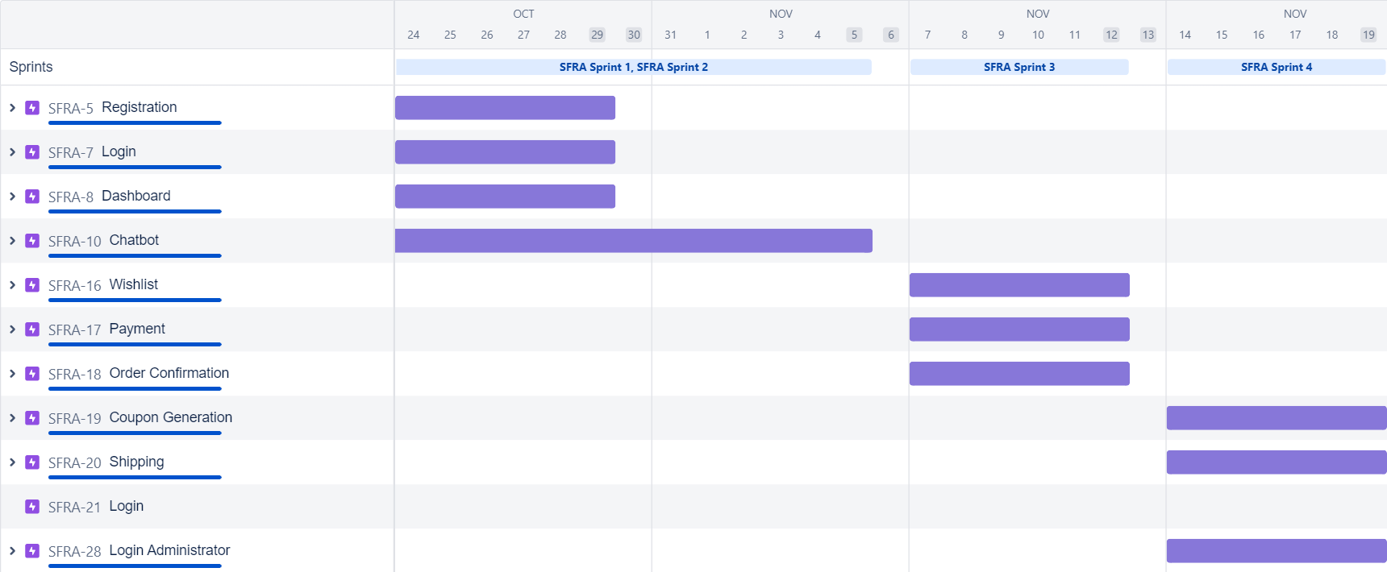

**Figure 6.3.1: Roadmap**

### Sprint 1 Report

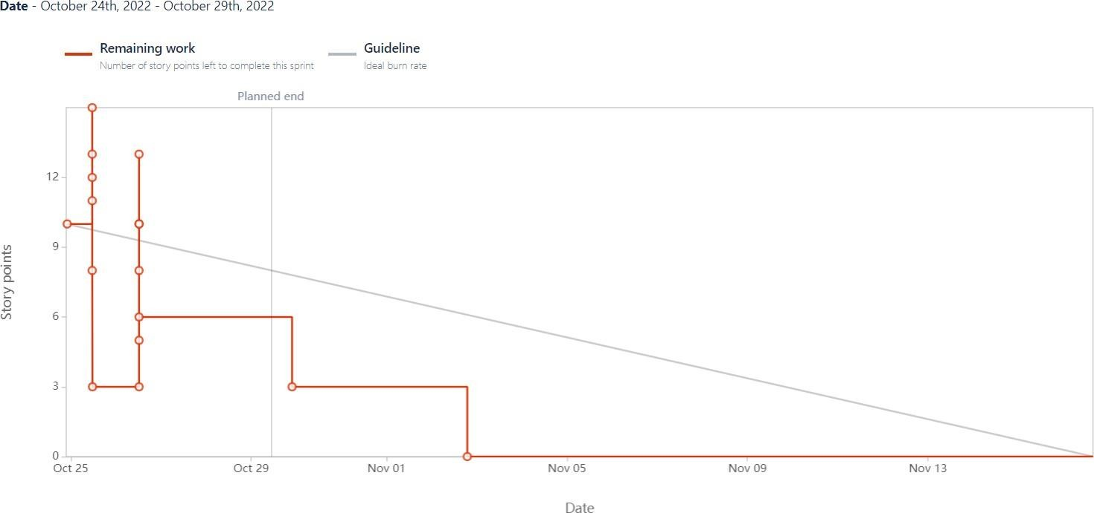

**Figure 6.3.2: Sprint 1 Report**

### Sprint 2 Report

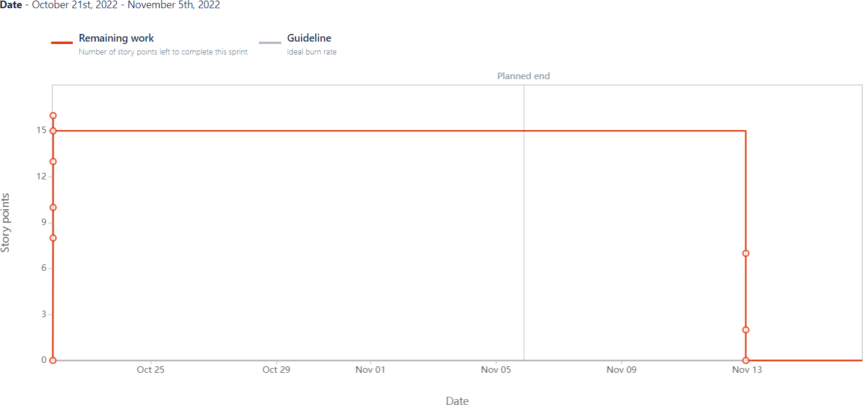

**Figure 6.3.3: Sprint 2 Report**

### Sprint 3 Report

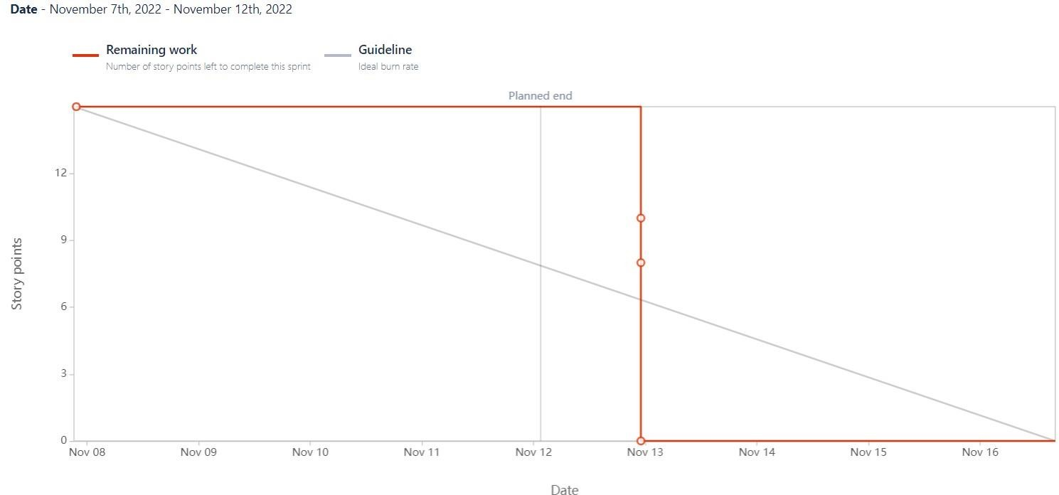

**Figure 6.3.2: Sprint 3 Report**

### Sprint 4 Report

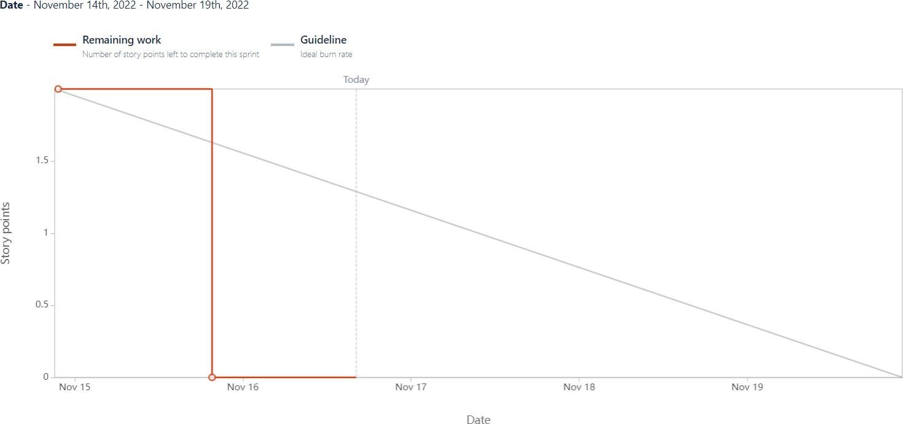

**Figure 6.3.4: Sprint 4 Report**

# CODING & SOLUTIONING

## Feature 1

### Chatbot:

A chatbot has been integrated with the application for recommending fashion products based on the user's preference. For this, IBM Watson Assistant has been used. The chatbot, before suggesting products, asks the user few questions to learn about what the user wants. The chatbot retrieves the product details from the cloud, according to the customer responses to the questions being asked.

### Code:

**home.html**

<!DOCTYPE html>

<html lang="en" dir="ltr">

<head>

<meta name="viewport" content="width=device-width, initial-scale=1.0">

<title>Sash Vogue</title>

<link rel="icon" type="image/jpeg" href="{{url_for('redirect_to',link='https://s3.jp-tok.cloud-object- storage.appdomain.cloud/smartfashion2001/logo.jpeg')}}" sizes="200x200">

<link rel="stylesheet" [href="https://cdn.jsdelivr.net/npm/bootstrap@4.6.2/dist/css/bootstrap.min.css"](https://cdn.jsdelivr.net/npm/bootstrap%404.6.2/dist/css/bootstrap.min.css) integrity="sha384- xOolHFLEh07PJGoPkLv1IbcEPTNtaed2xpHsD9ESMhqIYd0nLMwNLD69Npy4HI+N" crossorigin="anonymous">

<link rel="stylesheet" href="{{url_for('static',filename='styles/styles.css')}}" type="text/css">

<link rel="preconnect" href="https://fonts.googleapis.com">

<link rel="preconnect" href="https://fonts.gstatic.com" crossorigin>

<link [href="https://fonts.googleapis.com/css2?family=Jost:wght@500&family=Quicksand:wght@300&fam](https://fonts.googleapis.com/css2?family=Jost%3Awght%40500&family=Quicksand%3Awght%40300&fami)i ly=Courgette&display=swap" rel="stylesheet">

<script src="https://kit.fontawesome.com/0a56e63d65.js" crossorigin="anonymous"></script>

<script src="https://ajax.googleapis.com/ajax/libs/jquery/3.4.1/jquery.min.js"></script>

</head>

<body

style="background:url({{url_for('redirect_to',link='https://s3.jp-tok.cloud-object- storage.appdomain.cloud/smartfashion2001/hmbg.png')}});background-repeat: no-repeat; background-attachment: fixed; background-position: center; background-size: cover; ">

{% from 'nav.html' import usedalot %}

{{usedalot(uname) }}

{% if uname!= None: %}

<div style="display:flex;">

<h4 style="font-family: 'Courgette', cursive;text-align: left;font-size: xx-large;margin-top: 8%;margin-left: 5%;font-weight: 100">Welcome {{uname}},</h4>

</div>

{% endif %}

{% if uname== None: %}

<div id="carouselExampleIndicators" class="carousel slide" style="margin:8% 3%;" data- ride="carousel">

{% else: %}

<div id="carouselExampleIndicators" class="carousel slide" style="margin:3%;" data- ride="carousel">

{% endif %}

<ol class="carousel-indicators">

<li data-target="#carouselExampleIndicators" data-slide-to="0" class="active"></li>

<li data-target="#carouselExampleIndicators" data-slide-to="1"></li>

<li data-target="#carouselExampleIndicators" data-slide-to="2"></li>

<li data-target="#carouselExampleIndicators" data-slide-to="3"></li>

<li data-target="#carouselExampleIndicators" data-slide-to="4"></li>

<li data-target="#carouselExampleIndicators" data-slide-to="5"></li>

<li data-target="#carouselExampleIndicators" data-slide-to="6"></li>

<li data-target="#carouselExampleIndicators" data-slide-to="7"></li>

</ol>

<div class="carousel-inner">

<div class="carousel-item ">

<a href="{{url_for('products_page',category='Kids',type='Boys T-Shirts')}}"> <img src="{{url_for('redirect_to',link='https://s3.jp-tok.cloud-object- storage.appdomain.cloud/smartfashion2001/kidspost.jpeg')}}" class="d-block w-100"

alt="..."></a>

</div>

<div class="carousel-item active">

<img src="{{url_for('redirect_to',link='https://s3.jp-tok.cloud-object- storage.appdomain.cloud/smartfashion2001/sale.jpeg')}}" class="d-block w-100" alt="...">

</div>

<div class="carousel-item">

<a href="{{url_for('products_page',category='Women',type='Ethnic Wear')}}"><img src="{{url_for('redirect_to',link='https://s3.jp-tok.cloud-object- storage.appdomain.cloud/smartfashion2001/ethnic.jpg')}}" class="d-block w-100" alt="...">

</a>

</div>

<div class="carousel-item ">

<a href="{{url_for('products_page',category='Women',type='Ethnic Wear')}}"><img src="{{url_for('redirect_to',link='https://s3.jp-tok.cloud-object- storage.appdomain.cloud/smartfashion2001/eid.jpeg')}}" class="d-block w-100" alt="...">

</a>

</div>

<div class="carousel-item">

<a href="{{url_for('products_page',category='Footwears',type='Men')}}">

<img src="{{url_for('redirect_to',link='https://s3.jp-tok.cloud-object- storage.appdomain.cloud/smartfashion2001/shoe.jpg')}}" class="d-block w-100" alt="..."></a>

</div>

<div class="carousel-item">

<a href="{{url_for('products_page',category='Men',type='Formals')}}">

<img src="{{url_for('redirect_to',link='https://s3.jp-tok.cloud-object- storage.appdomain.cloud/smartfashion2001/men.jpeg')}}" class="d-block w-100" alt="..."></a>

</div>

<div class="carousel-item">

<a href="{{url_for('products_page',category='Accessories',type='Men watches')}}">

<img src="{{url_for('redirect_to',link='https://s3.jp-tok.cloud-object- storage.appdomain.cloud/smartfashion2001/watch.jpeg')}}" class="d-block w-100" alt="..."></a>

</div>

<div class="carousel-item">

<a href="{{url_for('products_page',category='Women',type='Saree')}}">

<img src="{{url_for('redirect_to',link='https://s3.jp-tok.cloud-object- storage.appdomain.cloud/smartfashion2001/SAREE.jpg')}}" class="d-block w-100" alt="..."></a>

</div>

</div>

<a class="carousel-control-prev" href="#carouselExampleIndicators" role="button" data- slide="prev">

<span class="carousel-control-prev-icon" aria-hidden="true"></span>

<span class="sr-only">Previous</span>

</a>

<a class="carousel-control-next" href="#carouselExampleIndicators" role="button" data- slide="next">

<span class="carousel-control-next-icon" aria-hidden="true"></span>

<span class="sr-only">Next</span>

</a>

</div>

<div class="container">

<div class="row">

<div class="col-sm-12">

<div class="section-title">

<div class="divider"></div>

</div>

</div>

</div>

</div>

<section id="featuresec">

<h1 style="text-align:center; text-align: center;padding: 2%;font-weight: bolder;" class="h1style">F E A T U R E S</h1>

<div class="container">

<div class="row">

<div class="col-sm">

<h4>Free Shipping</h4>

<img src="{{url_for('redirect_to',link='https://s3.jp-tok.cloud-object- storage.appdomain.cloud/smartfashion2001/free-delivery.png')}}" class="icon">

<h4>Get Free shipping on all orders</h4>

</div>

<div class="col-sm">

<h4>Easy Returns</h4>

<img src="{{url_for('redirect_to',link='https://s3.jp-tok.cloud-object- storage.appdomain.cloud/smartfashion2001/product-return.png')}}" class="icon">

<h4>7 days Return Policy</h4>

</div>

<div class="col-sm">

<h4>Customer Support</h4>

<img src="{{url_for('redirect_to',link='https://s3.jp-tok.cloud-object- storage.appdomain.cloud/smartfashion2001/support.png')}}" class="icon">

<h4>24/7 Customer Support By our experts</h4>

</div>

</div>

</div>

</section>

<div class="container">

<div class="row">

<div class="col-sm-12">

<div class="section-title">

<div class="divider"></div>

</div>

</div>

</div>

</div>

<!--chatbot script -->

{% from 'footer.html' import footer %}

{{footer()}}

<script> window.watsonAssistantChatOptions = {

integrationID: "cba0c163-9f9a-42ce-b6e9-979ac6318cc0", // The ID of this integration. region: "au-syd", // The region your integration is hosted in.

serviceInstanceID: "245858a6-01a2-41fc-8707-d603be17b8f0", // The ID of your service instance.

onLoad: function(instance) { instance.render();

}

};

setTimeout(function() {

const t = document.createElement('script');

t.src = "https://web-chat.global.assistant.watson.appdomain.cloud/versions/" + (window.watsonAssistantChatOptions.clientVersion || 'latest') + "/WatsonAssistantChatEntry.js";

document.head.appendChild(t);

});

</script>

<script src="https://code.jquery.com/jquery-3.5.1.slim.min.js" integrity="sha384- DfXdz2htPH0lsSSs5nCTpuj/zy4C+OGpamoFVy38MVBnE+IbbVYUew+OrCXaRkfj" crossorigin="anonymous"></script>

<script [src="https://cdn.jsdelivr.net/npm/popper.js@1.16.0/dist/umd/popper.min.js"](https://cdn.jsdelivr.net/npm/popper.js%401.16.0/dist/umd/popper.min.js) integrity="sha384- Q6E9RHvbIyZFJoft+2mJbHaEWldlvI9IOYy5n3zV9zzTtmI3UksdQRVvoxMfooAo" crossorigin="anonymous"></script>

<script src="https://stackpath.bootstrapcdn.com/bootstrap/4.5.0/js/bootstrap.min.js" integrity="sha384- OgVRvuATP1z7JjHLkuOU7Xw704+h835Lr+6QL9UvYjZE3Ipu6Tp75j7Bh/kR0JKI"

crossorigin="anonymous"></script>

<script src="{{url_for('static',filename='script.js')}}" />

<script src="https://kit.fontawesome.com/0a56e63d65.js" crossorigin="anonymous"></script>

</body>

</html>

## Feature 2

### Coupon Generation:

The application generates coupons based on the bill amount and birthday of a customer. It is user's wish to apply coupon for deduction in the amount or they can save it for later. If applied, the amount is reduced from the bill amount generated and the net price is paid by the customer.

### Code:

**main.py**

#payment page @app.route("/payment",methods=('GET','POST')) def payment_pg():

userid = session.get('logged_in_userid', None) uname = session.get('logged_in_username', None) arr = fetch_cartarr(userid) actualmon=datetime.date.today().month actualday=datetime.date.today().day

amtarr = totamtcalculation(arr) print(amtarr)

if request.method == 'POST': #coupon generation if bill amount > 1000 print("success")

couponcode=request.form['couponcode'] print(couponcode) address=request.form['address'] print(amtarr)

updateaddr="UPDATE user SET address='"+address+"' WHERE userid='"+userid+"'" ibm_db.exec_immediate(conn, updateaddr)

if(len(arr)!=0): #birthdaycoupon generation if (couponcode == 'shop25sv'):

amtarr[2] = amtarr[2] - (amtarr[2] * 0.25) elif (couponcode == 'shi30obd'):

amtarr[2] = amtarr[2] - (amtarr[2] * 0.3) elif (couponcode == 'sash50sma'):

amtarr[2] = amtarr[2] - (amtarr[2] * 0.5) elif (couponcode == 'HBD60SAN'):

amtarr[2] = amtarr[2] - (amtarr[2] * 0.6) print(amtarr)

query="select DOB,address from user where userid='"+userid+"'" stmt = ibm_db.exec_immediate(conn, query)

res = ibm_db.fetch_tuple(stmt) userdob=datetime.datetime.strptime(str(res[0]), "%Y-%m-%d") userdobmon=userdob.month

userdobday=userdob.day

if(userdobmon == actualmon and userdobday == actualday): birthdaycoupon=True

else:

birthdaycoupon=False

return render_template("payment.html",netamt=amtarr[2],birthdaycoupon=birthdaycoupon,userid=userid,res

=res,uname=uname)

## Database Schema

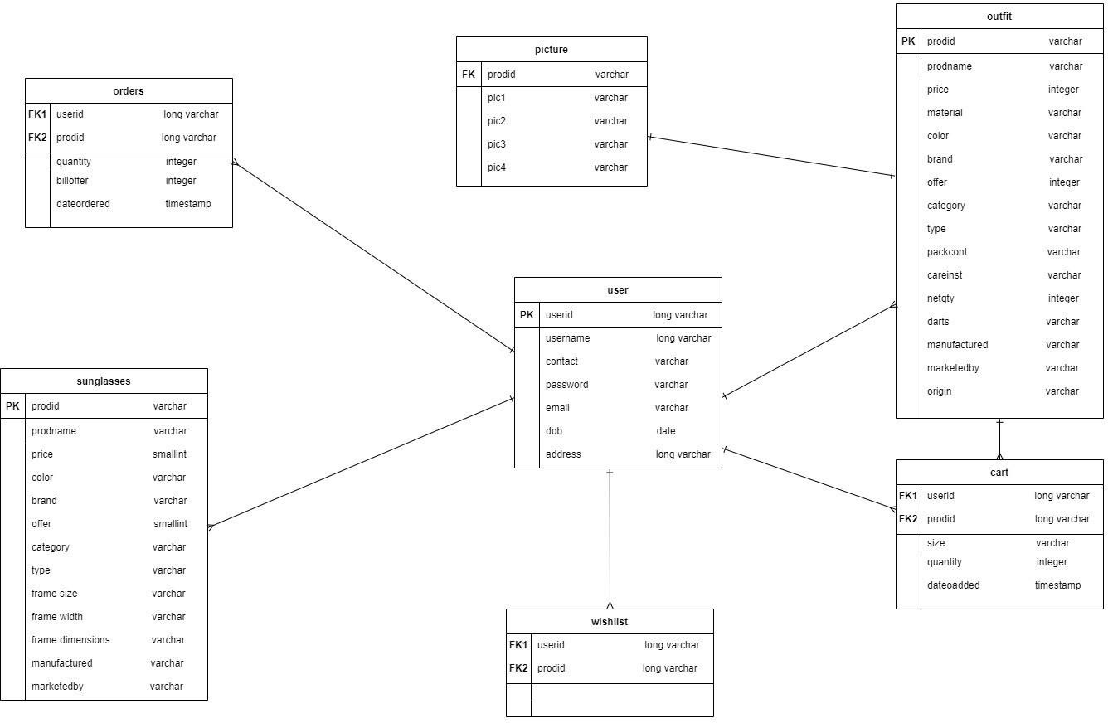

**Figure 7.3.1: Database Schema Diagram**

# TESTING

## Test Cases

### Sprint 1

**Table 8.1.1: Sprint 1 Test Cases**

|  |  |  |  |  |
| --- | --- | --- | --- | --- |
| **Test case**  **ID** | LoginPage_TC_  OO2 | LoginPage_TC_O  O3 | LoginPage_TC_O  O4 | LoginPage_TC_O  O5 |
| **Feature**  **Type** | UI | Functional | Functional | Functional |
| **Component** | Home Page | Home page | Login page | Login page |
| **Test Scenario** | Verify if if the UI elements in Login/Signup popup | Verify if user is able to log into application with Valid credentials | Verify if user is able to log into application with InValid credentials | Verify if user is able to log into application with InValid credentials |
| **Pre- Requisite** | The user must know his/her login credentials like username and password. | The user must know his/her login credentials like username and password. | Credentials | Credentials |
| **Steps To Execute** | 1. Enter URL and click go. 2. Click on My Account dropdown button. 3. Verify if login/Singup popup with below UI elements:    1. email text box    2. password text box   c.Login button d.New customer?  Create account  Link | 1. Enter URL(websiteurl) and click go. 2. Click on My Account dropdown button. 3. Enter Valid username/email in Email text box. 4. Enter valid password in password text box. 5. Click on login button. | 1. Enter URL(https://shope nzer.com/) and click go. 2. Click on My Account dropdown button. 3. Enter InValid username/email in Email text box. 4. Enter valid password in password text box. 5. Click on login button. | 1. Enter URL(https://shopen zer.com/) and click go. 2. Click on My Account dropdown button. 3. Enter InValid username/email in Email text box. 4. Enter Invalid password in password text box. 5. Click on login button. |

|  |  |  |  |  |
| --- | --- | --- | --- | --- |
| **Test Data** | [http://159.122.1](http://159.122.0.1/) 81.169:32087/ | Username:  shirlsrocks password: 123 | Username:  shirleyrocks password: 123 | Username:  shirleyrocks password:345 |
| **Expected Result** | Application should show below UI elements: a.username text box  b.password text box  c.Login button with orange colour  d.New customer? Create account  link | User should be able to go to home page of the website with the username displayed in the home page. | Application should show 'Invalid credentials. Please enter corect details' validation message. | Application should show 'Invalid credentials. Please enter corect details' validation message. |
| **Actual**  **Result** | Working as  expected | Working as  expected | Working as  expected | Working as  expected |
| **Status** | Pass | Pass | Pass | Pass |
| **Comments** | The login page  elements are as mentioned. | - | - | - |
| **TC for**  **Automatio n(Y/N)** | - | - | - | - |
| **BUG ID** | - | - | - | - |

### Sprint 2

**Table 8.1.2: Sprint 2 Test Cases**

|  |  |  |  |  |
| --- | --- | --- | --- | --- |
| **Test case ID** | Product_Det_Pag  e_TC_OO1 | Product_Page_TC  _OO2 | Home_Page_TC_  003 | Home_Page_TC_0  04 |
| **Feature**  **Type** | Functional | UI | Functional | Functional |

|  |  |  |  |  |
| --- | --- | --- | --- | --- |
| **Component** | Product Detail  Page | Product page | Chatbot | Chatbot |
| **Test Scenario** | Adding Products to the cart | Verify if the user can view the product details | Verify if whether the chatbot is recommending the products | Verify if whether the user is provided with alternative combinations if the user is not satisfied with the  recommendations |
| **Pre- Requisite** | Users should register with the website to add products to the  cart | - | - | - |
| **Steps To Execute** | 1. Enter URL and click go 2. Explore the products and add them to the cart. | 1. Enter URL (website URL) and click go 2. Click the product you want to view | 1. Enter URL (website URL) and click go 2. Click the chatbot 3. Ask some   questions. | 1. Enter URL (website URL) and click go 2. Click the chatbot 3. Tell I'm not satisfied |
| **Test Data** | [http://159.122.18](http://159.122.0.18/)  1.169:32087/ | [http://159.122.181](http://159.122.0.181/)  .169:32087/ | [http://159.122.18](http://159.122.0.18/)  1.169:32087/ | [http://159.122.181.1](http://159.122.181.1/)  69:32087/ |
| **Expected Result** | The application should show below UI elements:  a. Product details | Users should be able to go to the home page of our website with the username displayed on the  home page. | A chatbot is recommending the products | Chatbot is recommending alternatives. |
| **Actual Result** | Working as expected | Working as expected | Working as  expected | Working as  expected |
| **Status** | Pass | Pass | Pass | Pass |
| **Comments** | - | - | - | - |
| **TC for**  **Automation (Y/N)** | - | - | - | - |

|  |  |  |  |  |
| --- | --- | --- | --- | --- |
| **BUG ID** | - | - | - | - |

### Sprint 3

**Table 8.1.3: Sprint 3 Test Cases**

|  |  |  |  |
| --- | --- | --- | --- |
| **Test case ID** | Product_Page_TC_OO1 | Payment_Page_TC_O  O2 | PaymentPage_TC_O  O3 |
| **Feature Type** | Functional | Functional | Functional |
| **Component** | Products Page | Payment page | Payment page |
| **Test Scenario** | Verify if if the user can add products to the wish list | Verify if if the user can  make payment at the checkout page. | Verify if if the user  can receive an order confirmation mail |
| **Pre-Requisite** | User should have signed in the website. | 1. User should have signed in the website. 2. User should have facilities for netbanking to use 3rd party payment   services. | 1. User should have. signed in the website. 2. User should have email ID. |
| **Steps To Execute** | 1. Enter URL and click go. 2. Explore the products. 3. Add the products to the wish list. | 1. Enter URL (website URL) and click go. 2. Click on the My Account dropdown button. 3. Add products to the cart. 4. Click ''Proceed to Buy". 5. Click the payment   option you want to avail. | 1. Enter the URL. 2. Make payment. |
| **Test Data** | http://159.122.181.169:3208  7/ | [http://159.122.181.169:](http://159.122.181.169/)  32087/ | [http://159.122.181.16](http://159.122.181.16/)  9:32087/ |
| **Expected Result** | Products are added to the wish list. | The user should be able to make payments. | The user should be  able to receive a confirmation mail. |

|  |  |  |  |
| --- | --- | --- | --- |
| **Actual Result** | Working as expected | Working as expected | Working as expected |
| **Status** | Pass | Pass | Pass |
| **Comments** | - | - | - |
| **TC for**  **Automation(Y/ N)** | - | - | - |
| **BUG ID** | - | - | - |

### Sprint 4

**Table 8.1.4: Sprint 4 Test Cases**

|  |  |  |  |
| --- | --- | --- | --- |
| **Test case ID** | Product_Page_TC_OO1 | Payment_Page_TC_O  O2 | PaymentPage_TC_O  O3 |
| **Feature Type** | Functional | Functional | Functional |
| **Component** | Products Page | Payment page | Payment page |
| **Test Scenario** | Verify if if the user can add products to the wish list. | Verify if if the user can make payment at the checkout page. | Verify if if the user is able to receive an order confirmation  mail. |
| **Pre-Requisite** | - | - | - |
| **Steps To Execute** | 1. Enter URL and click go. 2. Explore the products. 3. Add the products to the wish list. | 1. Enter URL (website URL) and click go 2. Click on the My Account dropdown button 3. Add products to the cart 4. Click ''Proceed to buy" 5. Click the payment   option you want to avail. | 1. Enter the URL. 2. Make payment. |
| **Test Data** | http://159.122.181.169:3208  7/ | [http://159.122.181.169:](http://159.122.181.169/)  32087/ | [http://159.122.181.16](http://159.122.181.16/)  9:32087/ |
| **Expected Result** | Products are added to the wishlist | The user should be able to make payments. | The user should be able to receive a |

|  |  |  |  |
| --- | --- | --- | --- |
|  |  |  | confirmation mail. |
| **Actual Result** | Working as expected | Working as expected | Working as expected |
| **Status** | Pass | Pass | Pass |
| **Comments** | - | - | - |
| **TC for**  **Automation(Y/ N)** | - | - | - |
| **BUG ID** | - | - | - |

## User Acceptance Testing

### Purpose of Document

The purpose of this document is to briefly explain the test coverage and open issues of the Smart Fashion Recommender project at the time of the release to User Acceptance Testing (UAT).

### Defect Analysis

This report shows the number of resolved or closed bugs at each severity level , and how they are resolved.

**Table 8.2.1: Defect Analysis**

|  |  |  |  |  |
| --- | --- | --- | --- | --- |
|  | **Total Cases** | **Not Tested** | **Fail** | **Pass** |
| Print Engine | 7 | 0 | 0 | 7 |
| Client Application | 51 | 0 | 0 | 51 |
| Security | 2 | 0 | 0 | 2 |
| Outsource Shipping | 3 | 0 | 0 | 3 |

**Table 8.2.2: Test Case Analysis**

|  |  |  |  |  |  |
| --- | --- | --- | --- | --- | --- |
| **Resolution** | **Severity 1** | **Severity 2** | **Severity 3** | **Severity 4** | **Subtotal** |
| By Design | 10 | 4 | 2 | 3 | 19 |
| Duplicate | 1 | 0 | 3 | 0 | 4 |
| External | 2 | 3 | 0 | 1 | 6 |
| Fixed | 11 | 2 | 4 | 20 | 37 |
| Not Reproduced | 0 | 0 | 0 | 0 | 0 |
| Skipped | 3 | 0 | 1 | 1 | 5 |
| Won't Fix | 0 | 5 | 2 | 1 | 8 |
| Totals | 24 | 14 | 13 | 26 | 79 |

# RESULTS

## 9.1 Performance Metrics

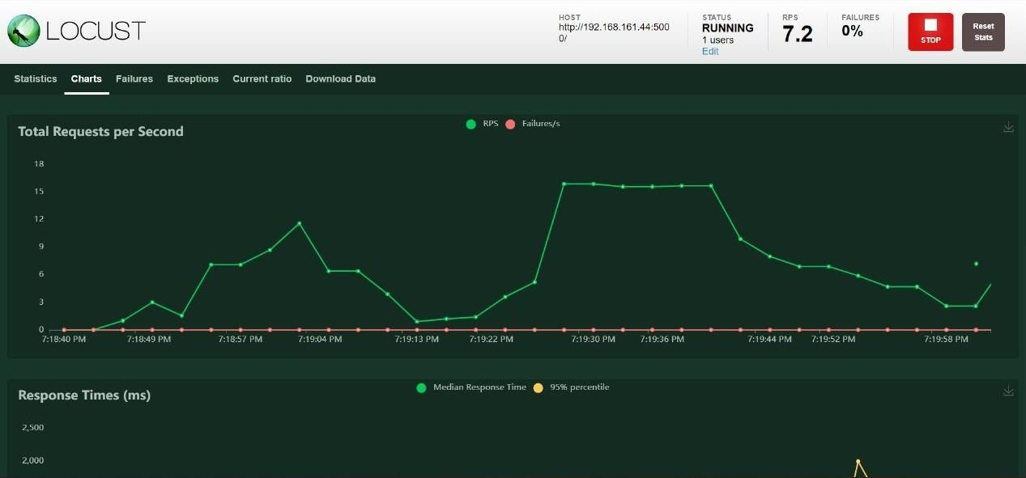

**Figure 9.1.1**

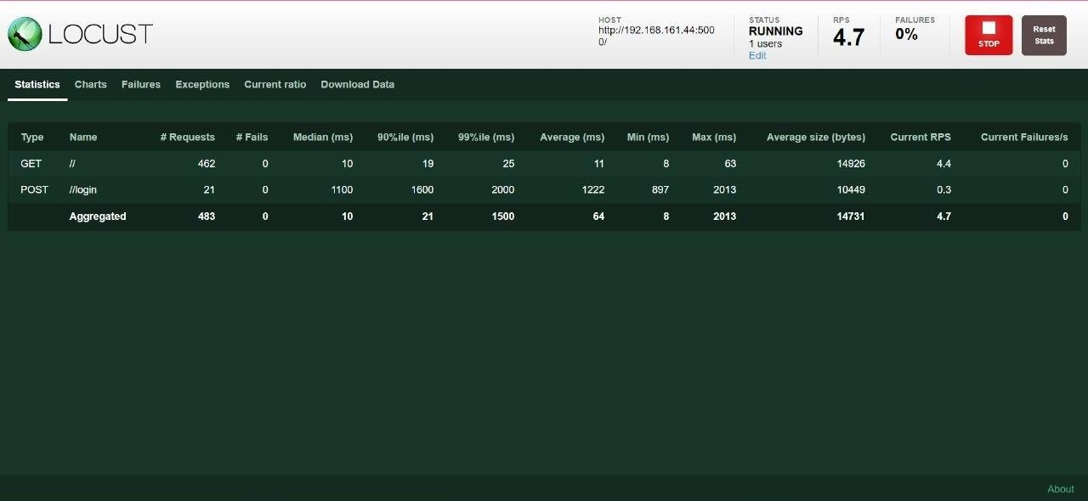

**Figure 9.1.2**

# ADVANTAGES & DISADVANTAGES

## Advantages

1. Customers can save time by shopping online by selecting the item as per their choice without any hassle of going to a mall or a physical store for buying fashion products.
2. They can purchase products easily with the help of chatbot which is available 24/7 to assist them.
3. Customers can save money with the deals provided.
4. Users can save money by applying for coupons and get more trendy products with new offers and deals.
5. They do not have to stand in queues in cash counters to pay for the products.

## Disadvantages

1.The sad part of online shopping is, customer cannot touch the product and feel how it is. 2.User may get disappointed if the expected product differs by color or size.

1. At times, the user will be frustrated if the products are damaged during delivery or if some parts are missing.
2. User may get annoyed if the product is not delivered at the estimated date.
3. Sometimes just to avail free shipping, user end up shopping more than your requirement.

# CONCLUSION

Technology has made significant progress over the years to provide consumers with a better online shopping experience. Online shopping has opened up doors to many small retailers that would never be in business, if they had to incur the high cost of owning a fashion store. The integration of chatbot helps consumers to obtain referrals according to their interest and even their questions are answered, making the client more active within the site. The bottom line is that, everyone benefits, both customers and vendor.

# FUTURE SCOPE

All walks of life wish for a simpler lifestyle. As a future enhancement, this application will further includes features like color combination recommendation (suggest colors that better match the color that the user is giving the virtual assistant), PO tracking, image search, show recently viewed products without logging into account for better user experience.

# APPENDIX

## Source Code

**Directory Structure**

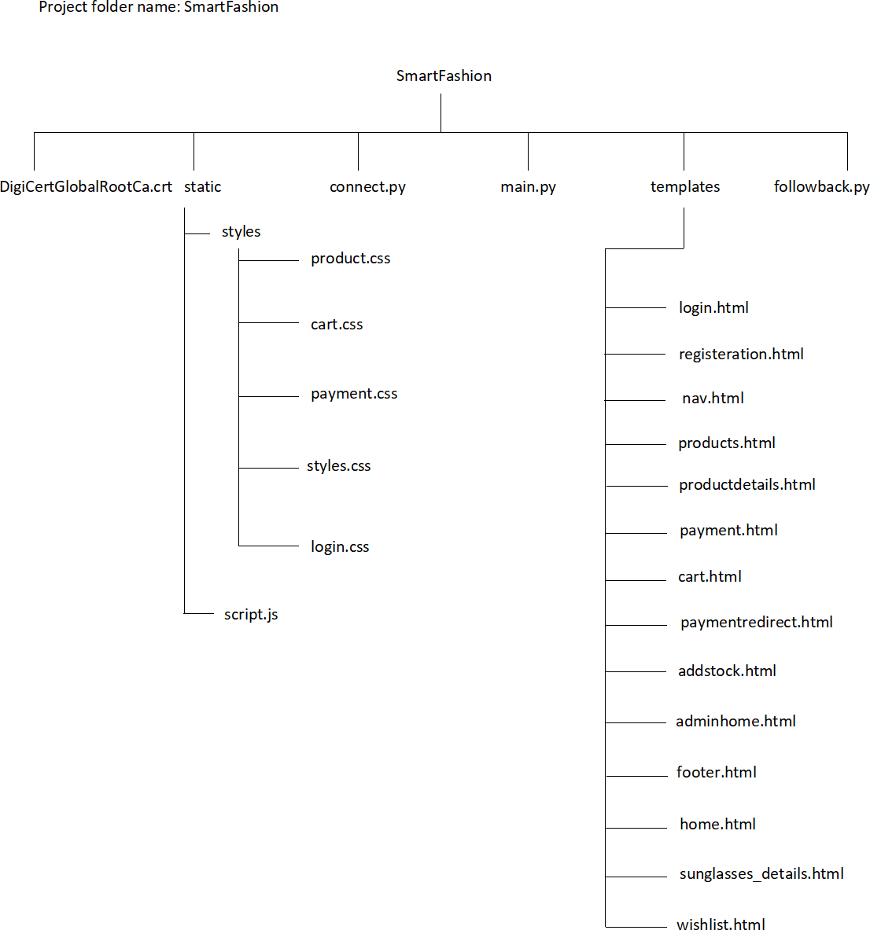

**Figure 13.1: Project Directory (For Reference)**

### main.py

from flask import * from connect import * import datetime

from urllib.parse import urlparse import smtplib

import random

from followback import * app= Flask( name )

app.config['SECRET_KEY'] = 'df0331cefc6c2b9a5d0208a726a5d1c0fd37324feba25506' app= Flask( name )

app.config['SECRET_KEY'] = 'df0331cefc6c2b9a5d0208a726a5d1c0fd37324feba25506' app.config['MAIL_SERVER']='smtp.gmail.com'

app.config['MAIL_PORT'] = 587

app.config['MAIL_USERNAME'] = 'fashionatsashvogue@gmail.com' app.config['MAIL_PASSWORD'] = 'nhmhbqmdeuxrhvwv' app.config['MAIL_USE_TLS'] = True

app.config['MAIL_USE_SSL'] = False mail = Mail(app)

#generating email

def mail_service(mailid,sub,body): try:

msg = [Message(sub,sender="fashionatsashvogue@gmail.com",recipients=[mailid])](mailto:fashionatsashvogue@gmail.com) msg.body = body

mail.send(msg) print("Sent")

except Exception as e: print("error")

#cart @app.route("/cart",methods=('GET','POST')) def cart_page():

userid=session.get('logged_in_userid', None) uname = session.get('logged_in_username', None) arr = fetch_cartarr(userid)

amtarr=totamtcalculation(arr) if request.method == 'POST':

prodid = request.form['prodid'] print(prodid+"PRODID FROM CART") print(arr)

flag = 0

for cartitems in arr:

if (cartitems[6] == prodid and cartitems[8] > 1): flag = 1

updatequery = "UPDATE cart set quantity=quantity-1 where prodid='" + prodid + "'" ibm_db.exec_immediate(conn, updatequery)

if (flag != 1):

querycart = "DELETE from cart where prodid='" + prodid + "'" ibm_db.exec_immediate(conn, querycart)

return render_template("cart.html",cartarr=arr,totcost=amtarr[0],totdis=amtarr[1],netamt=amtarr[2],uname=u name,lencartarr=len(arr))

#home page @app.route("/") def home_page():

logged_in_username = session.get('logged_in_username', None) logged_in_userid = session.get('logged_in_userid', None)

return render_template("home.html",uname=logged_in_username,userid=logged_in_userid)

#logout page @app.route("/logout") def logout_pg():

session.clear()

return redirect(url_for('loginpage'))

#external page @app.route('/redirect_to') def redirect_to():

link = request.args.get('link', '/') return redirect(link), 301

#registration page @app.route("/register",methods=('GET','POST')) def regpage():

if request.method == 'POST':

sub="Verify your email for Sash Vogue" form_checkvals = request.form.getlist("checkval")

userid=str(random.randint(16565565445345,96565565445345)) email = request.form['mail']

dob=request.form['DOB']

username = request.form['username'] password=request.form['password'] contact=request.form['contact'] address=request.form['address'] query="insert into user

values('"+userid+"','"+username+"','"+contact+"','"+password+"','"+email+"','"+dob+"','"+address+"')" stmt=ibm_db.exec_immediate(conn,query)

rowcount=ibm_db.num_rows(stmt) subject="Verify email for Sash Vogue"

body="You have been successfully registered with Sash Vogue Community."

if(len(form_checkvals) !=0 and form_checkvals[0]=='yes'): mail_service(email,subject,body)

return redirect(url_for('loginpage')) return render_template("registration.html")

#login page @app.route("/login",methods=('GET','POST')) def loginpage():

type='user'

if request.method == 'POST': uname = request.form['uname']

password = request.form['password']

query = "select COUNT(*)from user where username='"+uname+"' and password='"+password+"'"

stmt5 = ibm_db.exec_immediate(conn,query) row = ibm_db.fetch_tuple(stmt5)

query1="select * from user where username='"+uname+"' and password='"+password+"'" stmt2= ibm_db.exec_immediate(conn,query1)

row2= ibm_db.fetch_tuple(stmt2) if(row[0] ==1 ):

session['logged_in_username'] = uname session['logged_in_userid'] = row2[0] session['logged_in_usermail']=row2[4] print(row2[4])

print(row2[1])

return redirect(url_for('home_page')) else:

flash("Invalid credentials! Please enter correct details") return render_template("login.html",type=type)

#redirect to payemnet process page @app.route("/paymentredirect") def payment_redirect():

userid = session.get('logged_in_userid', None) umail=session.get('logged_in_usermail',None) arr=fetch_cartarr(userid)

message = """Subject: Order Confirmation

Thank you for your order!. Your order has been received. Continue Shopping with Sash Vogue""" for item in arr:

temp=item[1]-(item[1]*item[8]*item[7]/100) bill=int(temp)

dt=datetime.datetime.now()

query="insert into orders values(?,?,?,?,?)" stmt=ibm_db.prepare(conn,query) ibm_db.bind_param(stmt,1,userid) ibm_db.bind_param(stmt, 2,item[6]) ibm_db.bind_param(stmt, 3,item[8])

ibm_db.bind_param(stmt, 4, bill)

ibm_db.bind_param(stmt, 5, dt) ibm_db.execute(stmt) mail_service(email,subject,body)

return redirect(url_for('redirect_to',link='https://rzp.io/l/Ninl0NjQ')) #payment page

@app.route("/payment",methods=('GET','POST'))

def payment_pg():

userid = session.get('logged_in_userid', None) uname = session.get('logged_in_username', None) arr = fetch_cartarr(userid) actualmon=datetime.date.today().month actualday=datetime.date.today().day

amtarr = totamtcalculation(arr) print(amtarr)

if request.method == 'POST': #coupon generation if price >1000 print("success")

couponcode=request.form['couponcode'] print(couponcode) address=request.form['address'] print(amtarr)

updateaddr="UPDATE user SET address='"+address+"' WHERE userid='"+userid+"'" ibm_db.exec_immediate(conn, updateaddr)

if(len(arr)!=0): #birthdaycoupon generation if (couponcode == 'shop25sv'):

amtarr[2] = amtarr[2] - (amtarr[2] * 0.25) elif (couponcode == 'shi30obd'):

amtarr[2] = amtarr[2] - (amtarr[2] * 0.3) elif (couponcode == 'sash50sma'):

amtarr[2] = amtarr[2] - (amtarr[2] * 0.5) elif (couponcode == 'HBD60SAN'):

amtarr[2] = amtarr[2] - (amtarr[2] * 0.6) print(amtarr)

query="select DOB,address from user where userid='"+userid+"'" stmt = ibm_db.exec_immediate(conn, query)

res = ibm_db.fetch_tuple(stmt) userdob=datetime.datetime.strptime(str(res[0]), "%Y-%m-%d") userdobmon=userdob.month

userdobday=userdob.day #birthday coupon generation

if(userdobmon == actualmon and userdobday == actualday): birthdaycoupon=True

else:

birthdaycoupon=False

return render_template("payment.html",netamt=amtarr[2],birthdaycoupon=birthdaycoupon,userid=userid,res

=res,uname=uname)

#admin stocks page @app.route("/addstock") def add_Stockpg():

return render_template("addstock.html") @app.route("/adminlogin",methods=('GET','POST')) def adminloginpage():

type='admin'

if request.method == 'POST': actualuname='admin' actualpassword='123'

uname = request.form['uname'] password = request.form['password']

if(actualpassword == password and actualuname == uname ): return redirect(url_for('home_page'))

else:

flash("Invalid credentials! Please enter correct details") return render_template("login.html",type=type)

#admin page @app.route('/admin') def adminhomepage():

arr=[]

query="select prodid,prodname,category,type,brand,price from outfit ORDER BY prodid" stmt = ibm_db.exec_immediate(conn, query)

row = ibm_db.fetch_tuple(stmt) while (row):

arr.append(row) # appending all dictionaries in arr

row = ibm_db.fetch_tuple(stmt) # incrementing that is to next row return render_template("adminhome.html",prodarr=arr)

#product details @app.route("/productdetails/<category>/<type>/<prodid>",methods=('GET','POST')) def product_detailspg(category,type,prodid):

o = urlparse(request.base_url)

userid = session.get('logged_in_userid', None) uname = session.get('logged_in_username', None) if (request.method=='POST'):

if(uname !=None):

arr = fetch_cartarr(userid) insert_intocart(arr,prodid,category,userid,type) return redirect(url_for('cart_page'))

else:

flash("Oops! Seems like you haven't registered with us. Sign Up") api=fetchapi(category)

res18empty=False res19empty=False

query="select o.*,p.pic1,p.pic2,p.pic3,p.pic1 from outfit o inner join picture p on o.prodid=p.prodid where o.prodid='"+prodid+"'"

stmt = ibm_db.exec_immediate(conn, query) res = ibm_db.fetch_tuple(stmt)

pricedisplay= round(res[2] -(res[2]*res[6] / 100)) if ((res[18] == None) or (res[18] == "nil")):

res18empty = True

if( (res[19]==None) or (res[19]=="nil") ): res19empty=True

return render_template("productdetails.html",category=category,type=type,prodid=prodid,result=res,api=api,r es18empty=res18empty,res19empty=res19empty,pricedisplay=pricedisplay,hostname=o.hostname,port

=o.port,uname=uname)

#Accessories - Sunglass @app.route("/sunglasses_/<category>/<type>/<prodid>",methods=('GET','POST')) def sunglasses_detailspg(category,type,prodid):

o = urlparse(request.base_url) api=fetchapi(category)

uname = session.get('logged_in_username', None) userid = session.get('logged_in_userid', None)

if (request.method=='POST'): if (uname != None):

arr = fetch_cartarr(userid)

insert_intocart(arr, prodid, category, userid, type) else:

flash("Please login to add the products to cart") api=fetchapi(category)

query="select o.*,p.pic1,p.pic2,p.pic3,p.pic4,o.offer from sunglasses o inner join picture p on o.prodid=p.prodid where o.prodid='"+prodid+"'"

stmt = ibm_db.exec_immediate(conn, query) res = ibm_db.fetch_tuple(stmt)

pricedisplay = round(res[2] - (res[2] * res[17] / 100)) return

render_template("sunglasses_details.html",category=category,type=type,prodid=prodid,result=res,api= api,pricedisplay=pricedisplay,hostname=o.hostname,port=o.port,uname=uname)

#wishlist @app.route('/wishlist') def wishlist_pg():

userid = session.get('logged_in_userid', None)

uname = session.get('logged_in_username', None) arr=fetchwishlist(userid)

return render_template("wishlist.html",wishlistarr=arr,uname=uname)

#products page @app.route("/products/<category>/<type>",methods=('GET','POST')) def products_page(category,type):

arr=[]

userid = session.get('logged_in_userid', None) uname = session.get('logged_in_username', None) api=""

if(request.method=='POST'): prodid=request.form['prodid'] if(uname != None):

insertwishlist="insert into wishlist values ('"+userid+"','"+prodid+"')" ibm_db.exec_immediate(conn,insertwishlist)

else:

flash("Oops! Seems like you haven't registered with us. Sign Up")

if(type != "Sunglasses"): #since sunglasses differ some characteristics with other products need to create separate page.

api=fetchapi(category)

query="select o.prodid,o.prodname,o.brand,o.price,p.pic1,p.pic2,p.pic3,p.pic4,o.offer from outfit o inner join picture p on o.prodid=p.prodid where category='"+category+"' and type='"+type+"'"

stmt = ibm_db.exec_immediate(conn, query) row = ibm_db.fetch_tuple(stmt)

while (row):

arr.append(row) # appending all dictionaries in arr

row = ibm_db.fetch_tuple(stmt) # incrementing that is to next row

else:

api = fetchapi(category)

query = "select o.prodid,o.prodname,o.brand,o.price,p.pic1,p.pic2,p.pic3,p.pic4,o.offer from sunglasses o inner join picture p on o.prodid=p.prodid where category='"+category+"' and type='"+type+"'"

stmt = ibm_db.exec_immediate(conn, query) row = ibm_db.fetch_tuple(stmt)

while (row):

arr.append(row) # appending all dictionaries in arr

row = ibm_db.fetch_tuple(stmt) # incrementing that is to next row return

render_template("products.html",productsarr=arr,category=category,type=type,api=api,userid=userid,u name=uname)

if( name ==' main '): app.run(host ='0.0.0.0', port = 5000)

### followback.py

from connect import * from flask import * import datetime

#other use defined functions required def fetchapi(category):

api=""

if(category =='Women'):

api='https://s3.jp-tok.cloud-object-storage.appdomain.cloud/raspberryibmsfrappbucket/' elif (category == 'Men'):

api = 'https://s3.jp-tok.cloud-object-storage.appdomain.cloud/iraash/' elif (category == 'Accessories'):

api = 'https://s3.jp-tok.cloud-object-storage.appdomain.cloud/104084smartfashion/' elif (category == 'Kids'):

api = 'https://s3.jp-tok.cloud-object-storage.appdomain.cloud/iraash/' elif (category == 'Footwears'):

api = 'https://s3.jp-tok.cloud-object-storage.appdomain.cloud/smartfashion2001/' return api

def insert_intocart(arr,prodid,category,userid,type): dt=datetime.datetime.now()

if (type == 'Dresses' or type == 'Kurtis' or type == 'Palazzo' or type == 'Western' or category == 'Men' or category == 'Kids' or category == 'Footwears'):

size = request.form['sizeval'] else:

size = "nil" flag = 0

for cartitems in arr: #if already the user has added an item in cart quantity gets updated. if (cartitems[6] == prodid and cartitems[3]==size):

flag = 1

updatequery = "UPDATE cart set quantity=quantity+1 where prodid='" + prodid + "'" ibm_db.exec_immediate(conn, updatequery)

break

if (flag != 1):

querycart="insert into cart values(?,?,?,?,?)" stmt = ibm_db.prepare(conn, querycart) ibm_db.bind_param(stmt, 1, userid)

ibm_db.bind_param(stmt, 2, prodid)

ibm_db.bind_param(stmt, 3, size)

ibm_db.bind_param(stmt, 4, 1)

ibm_db.bind_param(stmt, 5, dt) ibm_db.execute(stmt)

def fetch_cartarr(userid): arr=[]

query = "select o.prodname,o.price,p.pic1,c.size,o.category,o.type,o.prodid,o.offer,c.quantity from outfit o inner join picture p on o.prodid=p.prodid INNER join cart c on c.prodid=p.prodid where userid='"+userid+"' ORDER BY c.dateoadded DESC"

stmt = ibm_db.exec_immediate(conn, query) row = ibm_db.fetch_tuple(stmt)

while (row):

arr.append(row) # appending all dictionaries in arr

row = ibm_db.fetch_tuple(stmt) # incrementing that is to next row for i in range(0, len(arr)):

arr[i] = list(arr[i])

for j in range(0, len(arr)): imageapi = fetchapi(arr[j][4]) arr[j][2] = imageapi + arr[j][2]

constlen = len(arr)

sunquery = "select o.prodname,o.price,p.pic1,c.size,o.category,o.type,o.prodid,o.offer,c.quantity from sunglasses o inner join picture p on o.prodid=p.prodid INNER join cart c on c.prodid=p.prodid where userid='"+userid+"' ORDER BY c.dateoadded DESC"

sunstmt = ibm_db.exec_immediate(conn, sunquery) sunrow = ibm_db.fetch_tuple(sunstmt)

while (sunrow):

arr.append(sunrow) # appending all dictionaries in arr

sunrow = ibm_db.fetch_tuple(sunstmt) # incrementing that is to next row for i in range(constlen, len(arr)):

arr[i] = list(arr[i])

for j in range(constlen, len(arr)): imageapi2 = fetchapi(arr[j][4]) arr[j][2] = imageapi2 + arr[j][2]

print(arr) return arr

def totamtcalculation(arr): totcost = 0

totdis = 0 amtarr=[]

for k in range(0, len(arr)):

totcost = totcost + (arr[k][1] * arr[k][8])

temp = (arr[k][1] * arr[k][8] * arr[k][7]) / 100 totdis = totdis + round(temp)

netamt = totcost - totdis

taxcalcnetamt = netamt + (netamt * 12) / 100 amtarr.append(int(totcost)) amtarr.append(int(totdis)) amtarr.append(int(taxcalcnetamt))

return amtarr

def fetchwishlist(userid): arr=[]

query = "select o.prodid,o.prodname,o.price,p.pic1,o.category,o.type,o.brand,o.offer from outfit o

inner join picture p on o.prodid=p.prodid INNER join wishlist w on w.prodid=p.prodid where userid='"

+ userid + "'"

stmt = ibm_db.exec_immediate(conn, query) row = ibm_db.fetch_tuple(stmt)

while (row):

arr.append(row) # appending all dictionaries in arr

row = ibm_db.fetch_tuple(stmt) # incrementing that is to next row for i in range(0, len(arr)):

arr[i] = list(arr[i])

for j in range(0, len(arr)): imageapi = fetchapi(arr[j][4]) arr[j][3] = imageapi + arr[j][3]

constlen = len(arr)

sunquery = "select o.prodid,o.prodname,o.price,p.pic1,o.category,o.type,o.brand,o.offer from sunglasses o inner join picture p on o.prodid=p.prodid INNER join wishlist w on w.prodid=p.prodid where userid='" + userid + "'"

sunstmt = ibm_db.exec_immediate(conn, sunquery) sunrow = ibm_db.fetch_tuple(sunstmt)

while (sunrow):

arr.append(sunrow) # appending all dictionaries in arr

sunrow = ibm_db.fetch_tuple(sunstmt) # incrementing that is to next row for i in range(constlen, len(arr)):

arr[i] = list(arr[i])

for j in range(constlen, len(arr)): imageapi2 = fetchapi(arr[j][4]) arr[j][3] = imageapi2 + arr[j][3]

return arr

### connect.py

#connecting to IBM Db2 import ibm_db

dsn_hostname = "9938aec0-8105-433e-8bf9- 0fbb7e483086.c1ogj3sd0tgtu0lqde00.databases.appdomain.cloud" # e.g.: "54a2f15b-5c0f-46df-8954- 7e38e612c2bd.c1ogj3sd0tgtu0lqde00.databases.appdomain.cloud"

dsn_uid = "tzg17937" # e.g. "abc12345"

dsn_pwd = "RxjZkDB5SpKoGhvS" # e.g. "7dBZ3wWt9XN6$o0J" dsn_driver = "{IBMDB2CL1}"

dsn_database = "bludb" # e.g. "BLUDB" dsn_port = "32459" # e.g. "32733" dsn_protocol = "TCPIP" # i.e. "TCPIP" dsn_security = "SSL" #i.e. "SSL dsn_cert="DigiCertGlobalRootCA.crt"

dsn = (

"DRIVER={0};"

"DATABASE={1};"

"HOSTNAME={2};"

"PORT={3};"

"PROTOCOL={4};"

"UID={5};"

"PWD={6};"

"SECURITY={7};"

"SSLServerCertificate={8};").format(dsn_driver, dsn_database, dsn_hostname, dsn_port, dsn_protocol, dsn_uid, dsn_pwd,dsn_security,dsn_cert)

try:

conn = ibm_db.connect(dsn, "", "")

print("Connected to database: ", dsn_database, "as user: ", dsn_uid, "on host: ", dsn_hostname) except:

print("Unable to connect: ", ibm_db.conn_errormsg())

# sql = "insert into user values('105','sahana@gmail.com','1234','sahanaparveen')" # ibm_db.exec_immediate(conn, sql)

print(dsn)

### addstock.html

<!DOCTYPE html>

<html>

<head>

<meta name="viewport" content="width=device-width, initial-scale=1.0">

<title>Sash Vogue</title>

<link rel="icon" type="image/jpeg" href="{{url_for('redirect_to',link='https://s3.jp-tok.cloud- object- storage.appdomain.cloud/smartfashion2001/logo.jpeg')}}" sizes="200x200">

<link rel="stylesheet" [href="https://cdn.jsdelivr.net/npm/bootstrap@4.6.2/dist/css/bootstrap.min.css"](https://cdn.jsdelivr.net/npm/bootstrap%404.6.2/dist/css/bootstrap.min.css) integrity="sha384- xOolHFLEh07PJGoPkLv1IbcEPTNtaed2xpHsD9ESMhqIYd0nLMwNLD69Npy4HI+N" crossorigin="anonymous">

<link rel="stylesheet" href="{{url_for('static',filename='styles/styles.css')}}" type="text/css">

<link rel="preconnect" href="https://fonts.googleapis.com">

<link rel="preconnect" href="https://fonts.gstatic.com" crossorigin>

<script src="{{url_for('static',filename='script.js')}}"/>

<script defer src="https://use.fontawesome.com/releases/v5.15.4/js/all.js"></script>

<script defer src="https://use.fontawesome.com/releases/v6.2.0/js/all.js"></script>

<link [href="https://fonts.googleapis.com/css2?family=Alex+Brush&family=Quicksand:wght@300&family](https://fonts.googleapis.com/css2?family=Alex%2BBrush&family=Quicksand%3Awght%40300&family)= Jost:wght@500&display=swap" rel="stylesheet">

<style> h1{

margin-top:5%; text-align:center; color:white;}

.row

{

margin-top:20px; margin-left:300px; margin-right:300px; display:flex; color:gray;

}

.row1

{

margin-top:20px; margin-left:300px; margin-right:300px; display:flex; color:gray;

}

.addstockbtn

{

margin: 2% 50%;

background: rgba(161,25,75,255); color: white;

font-weight: bolder;}

</style>

</head>

<body style="background:url({{url_for('redirect_to',link='https://s3.jp-tok.cloud-object- storage.appdomain.cloud/smartfashion2001/adminbg.jpg')}});background-repeat: OPACITY:0.4; no- repeat; background-attachment: fixed; background-position: center; background-size: cover; ">

<nav class="navbar navbar-expand-lg fixed-top " style="padding:0rem 1rem; background: black;">

<a class="navbar-brand" id="brand" style="color:white;">SASH VOGUE</a>

</nav>

<h1>ADD STOCK</h1>

<form>

<div class="row">

<div class="col">

<input type="text" class="form-control" placeholder="PRODID">

</div>

<div class="col">

<input type="text" class="form-control" placeholder="PRODNAME">

</div>

</div>

<div class="row">

<div class="col">

<input type="text" class="form-control" placeholder="PRICE">

</div>

<div class="col">

<input type="text" class="form-control" placeholder="MATERIAL">

</div>

</div>

<div class="row">

<div class="col">

<input type="text" class="form-control" placeholder="COLOR">

</div>

<div class="col">

<input type="text" class="form-control" placeholder="BRAND">

</div>

</div>

<div class="row">

<div class="col">

<input type="text" class="form-control" placeholder="OFFER">

</div>

<div class="col">

<input type="text" class="form-control" placeholder="CATEGORY">

</div>

</div>

<div class="row">

<div class="col">

<input type="text" class="form-control" placeholder="CAREINST">

</div>

<div class="col">

<input type="text" class="form-control" placeholder="NETQTY">

</div>

</div>

<div class="row">

<div class="col">

<input type="text" class="form-control" placeholder="DARTS">

</div>

<div class="col">

<input type="text" class="form-control" placeholder="ORIGIN">

</div>

</div>

<div class="row">

<div class="col">

<input type="text" class="form-control" placeholder="TYPE">

</div>

</div>

<div class="row1">

<div class="col">

<textarea type="text" class="form-control" rows="4"cols="40" placeholder="MARKETEDBY"></textarea>

</div>

<div class="col">

<textarea type="text" class="form-control" rows="4"cols="40" placeholder="PACKCONT"></textarea>

</div>

<div class="col">

<textarea type="text" class="form-control" rows="4"cols="40" placeholder="MANUFACTURED"></textarea>

</div>

</div>

<button class="addstockbtn btn">ADD</button>

</form>

</body>

</html>

### adminlogin.html

<!DOCTYPE html>

<html>

<head>

<meta name="viewport" content="width=device-width, initial-scale=1.0">

<title>Sash Vogue</title>

<link rel="icon" type="image/jpeg" href="{{url_for('redirect_to',link='https://s3.jp-tok.cloud- object-storage.appdomain.cloud/smartfashion2001/logo.jpeg')}}" sizes="200x200">

<link rel="stylesheet" [href="https://cdn.jsdelivr.net/npm/bootstrap@4.6.2/dist/css/bootstrap.min.css"](https://cdn.jsdelivr.net/npm/bootstrap%404.6.2/dist/css/bootstrap.min.css) integrity="sha384- xOolHFLEh07PJGoPkLv1IbcEPTNtaed2xpHsD9ESMhqIYd0nLMwNLD69Npy4HI+N" crossorigin="anonymous">

<link rel="stylesheet" href="{{url_for('static',filename='styles/styles.css')}}" type="text/css">

<link rel="preconnect" href="https://fonts.googleapis.com">

<link rel="preconnect" href="https://fonts.gstatic.com" crossorigin>

<script src="{{url_for('static',filename='script.js')}}"/>

<script defer src="https://use.fontawesome.com/releases/v5.15.4/js/all.js"></script>

<script defer src="https://use.fontawesome.com/releases/v6.2.0/js/all.js"></script>

<link [href="https://fonts.googleapis.com/css2?family=Alex+Brush&family=Quicksand:wght@300&family](https://fonts.googleapis.com/css2?family=Alex%2BBrush&family=Quicksand%3Awght%40300&family)= Jost:wght@500&display=swap" rel="stylesheet">

<style>

th, td { padding: 15px;

text-align: bottom;

}

table, th,tr, td {

border: 3px black solid; color:white;

}

tr:hover {background-color:black;

}

th{font-weight:700px;

font-family: "Times New Roman", Times, serif; background-color:black;

}

h1{text-align:center; color:white;margin:2%;}

</style>

</head>

<body style="background:url({{url_for('redirect_to',link='https://s3.jp-tok.cloud-object- storage.appdomain.cloud/smartfashion2001/adminbg.jpg')}});background-repeat: no-repeat; background-attachment: fixed; background-position: center; background-size: cover; ">

<nav class="navbar navbar-expand-lg fixed-top " style="padding:0rem 1rem; background: black;">

<a class="navbar-brand" id="brand" style="color:white;">SASH VOGUE</a>

<button class="btn" style="background: white;font-weight: bolder;margin-left: 70%;"

>ADD STOCK </button>

</nav>

<h1><b>STOCK DETAILS</b></h1>

<div class="stock" style=" margin: 0 5%;">

<table class="table table-hover">

<thead>

<tr>

<th scope="col">PRODUCT ID</th>

<th scope="col">PRODUCT NAME</th>

<th scope="col">CATEGORY</th>

<th scope="col">TYPE</th>

<th scope="col">STOCK</th>

<th scope="col">BRAND</th>

<th scope="col">PRICE</th>

</tr>

</thead>

<tbody>

{% for product in prodarr:%}

<tr>

<td>{{product[0]}}</td>

<td>{{product[1]}}</td>

<td>{{product[2]}}</td>

<td>{{product[3]}}</td>

<td>100</td>

<td>{{product[4]}}</td>

<td>{{product[5]}}</td>

</tr>

</div>

</body>

</html>

<tr>

{% endfor %}

</tbody>

</table>

### cart.html

<!DOCTYPE html>

<html lang="en" dir="ltr" [xmlns="http://www](http://www.w3.org/1999/html).w3.or[g/1999/html">](http://www.w3.org/1999/html)

<head>

<meta name="viewport" content="width=device-width, initial-scale=1.0">

<title>Sash Vogue</title>

<link rel="icon" type="image/jpeg" href="{{url_for('redirect_to',link='https://s3.jp-tok.cloud-object- storage.appdomain.cloud/smartfashion2001/logo.jpeg')}}" sizes="200x200">

<link rel="stylesheet" [href="https://cdn.jsdelivr.net/npm/bootstrap@4.6.2/dist/css/bootstrap.min.css"](https://cdn.jsdelivr.net/npm/bootstrap%404.6.2/dist/css/bootstrap.min.css) integrity="sha384- xOolHFLEh07PJGoPkLv1IbcEPTNtaed2xpHsD9ESMhqIYd0nLMwNLD69Npy4HI+N" crossorigin="anonymous">

<link rel="stylesheet" href="{{url_for('static',filename='styles/cart.css')}}" type="text/css">

<link rel="stylesheet" href="{{url_for('static',filename='styles/products.css')}}" type="text/css">

<link rel="preconnect" href="https://fonts.googleapis.com">

<link rel="preconnect" href="https://fonts.gstatic.com" crossorigin>

<script defer src="https://use.fontawesome.com/releases/v6.2.0/js/all.js"></script>

<script defer src="https://use.fontawesome.com/releases/v5.15.4/js/all.js"></script>

<link href="https://fonts.googleapis.com/css2?family=Source+Serif+Pro&display=swap" rel="stylesheet">

<link [href="https://fonts.googleapis.com/css2?family=Jost:wght@500&family=Lora:ital,wght@1,500&fam](https://fonts.googleapis.com/css2?family=Jost%3Awght%40500&family=Lora%3Aital%2Cwght%401%2C500&fami)i ly=Quicksand:wght@300&display=swap" rel="stylesheet">

<title>Sash Vogue</title>

</head>

<body>

{% from 'nav.html' import usedalot %}

{{ usedalot(uname) }}

<div class="path" style="margin: 7% 0% 0% 5%;">

<a href="{{url_for('home_page')}}">Home <i class="fa-solid fa-angle-right"></i></a>

<a href="">Cart</a>

</div>

<div class="main">

{% if( lencartarr != 0): %}

<div class="productscartdiv">

{% for cartitem in cartarr: %}

<div class="maincart">

<div class="cart">

{% if cartitem[5] == 'Sunglasses': %}

<a href="{{url_for('sunglasses_detailspg',category=cartitem[4],type=cartitem[5],prodid=cartitem[6])}}">

<img class="cartimg" src="{{url_for('redirect_to',link=cartitem[2])}}"></a>

{% else: %}

<a href="{{url_for('product_detailspg',category=cartitem[4],type=cartitem[5],prodid=cartitem[6])}}"><i mg class="cartimg" src="{{url_for('redirect_to',link=cartitem[2])}}"></a>

{% endif %}

</div>

<div class="cartdetails">

<form method="post">

<h4 class="cardtitle">{{cartitem[0]}}</h4>

<h6>Price: ₹{{(cartitem[1] -(cartitem[1]*cartitem[7] / 100))|round|int}}</h6>

{% if cartitem[3]!= "nil" %}

<h6>Size: {{cartitem[3]}}</h6>

{%endif%}

<h6>Quantity: {{cartitem[8]}}</h6>

<br />

<input type="hidden" value="{{cartitem[6]}}" name="prodid">

<input type="submit" name="submit" class="cartbtn btn" value="Remove">

</form>

</div>

</div>

{% endfor %}

</div>

{% endif %}

<!-- order card -->

{% if (lencartarr != 0): %}

<div class="ordercoupondiv">

<div class="ordercard">

<div>

<h3>Order details</h3>

<h6>Total Cost: ₹{{totcost}}</h6>

<h6>Total Discount: ₹{{totdis}}</h6>

<h6>Tax: 12% </h6>

<h6>Net Amount: ₹{{netamt}}</h6>

<a href="{{url_for('payment_pg')}}" class="orderbtn">Proceed to buy</a>

</div>

</div>

</div>

{% endif %}

{% if(lencartarr == 0): %}

<h3 style="text-align:center;">Your cart is empty!</h3>

{% endif %}

</div>

<script> window.watsonAssistantChatOptions = {

integrationID: "cba0c163-9f9a-42ce-b6e9-979ac6318cc0", // The ID of this integration. region: "au-syd", // The region your integration is hosted in.

serviceInstanceID: "245858a6-01a2-41fc-8707-d603be17b8f0", // The ID of your service instance. onLoad: function(instance) {

instance.render();

}

};

setTimeout(function() {

const t = document.createElement('script');

t.src = "https://web-chat.global.assistant.watson.appdomain.cloud/versions/" + (window.watsonAssistantChatOptions.clientVersion || 'latest') + "/WatsonAssistantChatEntry.js";

document.head.appendChild(t);

});

</script>

</body>

</html>

### footer.html

{% macro footer() %}

<footer class="page-footer font-small cyan darken-3" style="background-color: rgb(140,121,135, 0.6)">

<div class="footercontainer">

<div class="footerrow">

<div class="col-md-12 py-5">

<div class="mb-5 flex-center" style="margin-left: 40%; margin-top: 2%;">

<!-- Facebook -->

<a class="fb-ic">

<i class="fab fa-facebook-f fa-lg white-text mr-md-5 mr-3 fa-2x"> </i>

</a>

<!-- Twitter -->

<a class="tw-ic">

<i class="fab fa-twitter fa-lg white-text mr-md-5 mr-3 fa-2x"> </i>

</a>

<!--Linkedin -->

<a class="li-ic">

<i class="fab fa-linkedin-in fa-lg white-text mr-md-5 mr-3 fa-2x"> </i>

</a>

<!--Instagram-->

<a class="ins-ic">

<i class="fab fa-instagram fa-lg white-text mr-md-5 mr-3 fa-2x"> </i>

</a>

<!--Pinterest-->

<a class="pin-ic">

<i class="fab fa-pinterest fa-lg white-text fa-2x"> </i>

</a>

</div>

</div>

</div>

</div>

<!-- Footer Elements -->

<!-- Copyright -->

<div class="footer-copyright text-center py-3">© 2022 Copyright:

<a href="/" style="color:#3f363c; text-decoration:none;"> sashvogue.com</a>

</div>

<!-- Copyright -->

</footer>

<!-- Footer -->

{% endmacro %}

### home.html

<!DOCTYPE html>

<html lang="en" dir="ltr">

<head>

<meta name="viewport" content="width=device-width, initial-scale=1.0">

<title>Sash Vogue</title>

<link rel="icon" type="image/jpeg" href="{{url_for('redirect_to',link='https://s3.jp-tok.cloud-object- storage.appdomain.cloud/smartfashion2001/logo.jpeg')}}" sizes="200x200">

<link rel="stylesheet" [href="https://cdn.jsdelivr.net/npm/bootstrap@4.6.2/dist/css/bootstrap.min.css"](https://cdn.jsdelivr.net/npm/bootstrap%404.6.2/dist/css/bootstrap.min.css) integrity="sha384- xOolHFLEh07PJGoPkLv1IbcEPTNtaed2xpHsD9ESMhqIYd0nLMwNLD69Npy4HI+N" crossorigin="anonymous">

<link rel="stylesheet" href="{{url_for('static',filename='styles/styles.css')}}" type="text/css">

<link rel="preconnect" href="https://fonts.googleapis.com">

<link rel="preconnect" href="https://fonts.gstatic.com" crossorigin>

<link [href="https://fonts.googleapis.com/css2?family=Jost:wght@500&family=Quicksand:wght@300&fam](https://fonts.googleapis.com/css2?family=Jost%3Awght%40500&family=Quicksand%3Awght%40300&fami)i ly=Courgette&display=swap" rel="stylesheet">

<script src="https://kit.fontawesome.com/0a56e63d65.js" crossorigin="anonymous"></script>

<script src="https://ajax.googleapis.com/ajax/libs/jquery/3.4.1/jquery.min.js"></script>

</head>

<body

style="background:url({{url_for('redirect_to',link='https://s3.jp-tok.cloud-object- storage.appdomain.cloud/smartfashion2001/hmbg.png')}});background-repeat: no-repeat; background-attachment: fixed; background-position: center; background-size: cover; ">

{% from 'nav.html' import usedalot %}

{{usedalot(uname) }}

{% if uname!= None: %}

<div style="display:flex;">

<h4 style="font-family: 'Courgette', cursive;text-align: left;font-size: xx-large;margin-top:

8%;margin-left: 5%;font-weight: 100">Welcome {{uname}},</h4>

</div>

{% endif %}

{% if uname== None: %}

<div id="carouselExampleIndicators" class="carousel slide" style="margin:8% 3%;" data- ride="carousel">

{% else: %}

<div id="carouselExampleIndicators" class="carousel slide" style="margin:3%;" data- ride="carousel">

{% endif %}

<ol class="carousel-indicators">

<li data-target="#carouselExampleIndicators" data-slide-to="0" class="active"></li>

<li data-target="#carouselExampleIndicators" data-slide-to="1"></li>

<li data-target="#carouselExampleIndicators" data-slide-to="2"></li>

<li data-target="#carouselExampleIndicators" data-slide-to="3"></li>

<li data-target="#carouselExampleIndicators" data-slide-to="4"></li>

<li data-target="#carouselExampleIndicators" data-slide-to="5"></li>

<li data-target="#carouselExampleIndicators" data-slide-to="6"></li>

<li data-target="#carouselExampleIndicators" data-slide-to="7"></li>

</ol>

<div class="carousel-inner">

<div class="carousel-item ">

<a href="{{url_for('products_page',category='Kids',type='Boys T-Shirts')}}"> <img src="{{url_for('redirect_to',link='https://s3.jp-tok.cloud-object- storage.appdomain.cloud/smartfashion2001/kidspost.jpeg')}}" class="d-block w-100"

alt="..."></a>

</div>

<div class="carousel-item active">

<img src="{{url_for('redirect_to',link='https://s3.jp-tok.cloud-object- storage.appdomain.cloud/smartfashion2001/sale.jpeg')}}" class="d-block w-100" alt="...">

</div>

<div class="carousel-item">

<a href="{{url_for('products_page',category='Women',type='Ethnic Wear')}}"><img src="{{url_for('redirect_to',link='https://s3.jp-tok.cloud-object- storage.appdomain.cloud/smartfashion2001/ethnic.jpg')}}" class="d-block w-100" alt="...">

</a>

</div>

<div class="carousel-item ">

<a href="{{url_for('products_page',category='Women',type='Ethnic Wear')}}"><img src="{{url_for('redirect_to',link='https://s3.jp-tok.cloud-object- storage.appdomain.cloud/smartfashion2001/eid.jpeg')}}" class="d-block w-100" alt="...">

</a>

</div>

<div class="carousel-item">

<a href="{{url_for('products_page',category='Footwears',type='Men')}}">

<img src="{{url_for('redirect_to',link='https://s3.jp-tok.cloud-object- storage.appdomain.cloud/smartfashion2001/shoe.jpg')}}" class="d-block w-100" alt="..."></a>

</div>

<div class="carousel-item">

<a href="{{url_for('products_page',category='Men',type='Formals')}}">

<img src="{{url_for('redirect_to',link='https://s3.jp-tok.cloud-object- storage.appdomain.cloud/smartfashion2001/men.jpeg')}}" class="d-block w-100" alt="..."></a>

</div>

<div class="carousel-item">

<a href="{{url_for('products_page',category='Accessories',type='Men watches')}}">

<img src="{{url_for('redirect_to',link='https://s3.jp-tok.cloud-object- storage.appdomain.cloud/smartfashion2001/watch.jpeg')}}" class="d-block w-100" alt="..."></a>

</div>

<div class="carousel-item">

<a href="{{url_for('products_page',category='Women',type='Saree')}}">

<img src="{{url_for('redirect_to',link='https://s3.jp-tok.cloud-object- storage.appdomain.cloud/smartfashion2001/SAREE.jpg')}}" class="d-block w-100" alt="..."></a>

</div>

</div>

<a class="carousel-control-prev" href="#carouselExampleIndicators" role="button" data- slide="prev">

<span class="carousel-control-prev-icon" aria-hidden="true"></span>

<span class="sr-only">Previous</span>

</a>

<a class="carousel-control-next" href="#carouselExampleIndicators" role="button" data- slide="next">

<span class="carousel-control-next-icon" aria-hidden="true"></span>

<span class="sr-only">Next</span>

</a>

</div>

<div class="container">

<div class="row">

<div class="col-sm-12">

<div class="section-title">

<div class="divider"></div>

</div>

</div>

</div>

</div>

<section id="featuresec">

<h1 style="text-align:center; text-align: center;padding: 2%;font-weight: bolder;" class="h1style">F E A T U R E S</h1>

<div class="container">

<div class="row">

<div class="col-sm">

<h4>Free Shipping</h4>

<img src="{{url_for('redirect_to',link='https://s3.jp-tok.cloud-object- storage.appdomain.cloud/smartfashion2001/free-delivery.png')}}" class="icon">

<h4>Get Free shipping on all orders</h4>

</div>

<div class="col-sm">

<h4>Easy Returns</h4>

<img src="{{url_for('redirect_to',link='https://s3.jp-tok.cloud-object- storage.appdomain.cloud/smartfashion2001/product-return.png')}}" class="icon">

<h4>7 days Return Policy</h4>

</div>

<div class="col-sm">

<h4>Customer Support</h4>

<img src="{{url_for('redirect_to',link='https://s3.jp-tok.cloud-object- storage.appdomain.cloud/smartfashion2001/support.png')}}" class="icon">

<h4>24/7 Customer Support By our experts</h4>

</div>

</div>

</div>

</section>

<div class="container">

<div class="row">

<div class="col-sm-12">

<div class="section-title">

<div class="divider"></div>

</div>

</div>

</div>

</div>

<!--chatbot script -->

{% from 'footer.html' import footer %}

{{footer()}}

<script> window.watsonAssistantChatOptions = {

integrationID: "cba0c163-9f9a-42ce-b6e9-979ac6318cc0", // The ID of this integration. region: "au-syd", // The region your integration is hosted in.

serviceInstanceID: "245858a6-01a2-41fc-8707-d603be17b8f0", // The ID of your service instance.

onLoad: function(instance) { instance.render();

}

};

setTimeout(function() {

const t = document.createElement('script');

t.src = "https://web-chat.global.assistant.watson.appdomain.cloud/versions/" + (window.watsonAssistantChatOptions.clientVersion || 'latest') + "/WatsonAssistantChatEntry.js";

document.head.appendChild(t);

});

</script>

<script src="https://code.jquery.com/jquery-3.5.1.slim.min.js" integrity="sha384- DfXdz2htPH0lsSSs5nCTpuj/zy4C+OGpamoFVy38MVBnE+IbbVYUew+OrCXaRkfj" crossorigin="anonymous"></script>

<script [src="https://cdn.jsdelivr.net/npm/popper.js@1.16.0/dist/umd/popper.min.js"](https://cdn.jsdelivr.net/npm/popper.js%401.16.0/dist/umd/popper.min.js) integrity="sha384-

Q6E9RHvbIyZFJoft+2mJbHaEWldlvI9IOYy5n3zV9zzTtmI3UksdQRVvoxMfooAo" crossorigin="anonymous"></script>

<script src="https://stackpath.bootstrapcdn.com/bootstrap/4.5.0/js/bootstrap.min.js" integrity="sha384- OgVRvuATP1z7JjHLkuOU7Xw704+h835Lr+6QL9UvYjZE3Ipu6Tp75j7Bh/kR0JKI"

crossorigin="anonymous"></script>

<script src="{{url_for('static',filename='script.js')}}" />

<script src="https://kit.fontawesome.com/0a56e63d65.js" crossorigin="anonymous"></script>

</body>

</html>

### login.html

<!DOCTYPE html>

<html>

<head>

<meta name="viewport" content="width=device-width, initial-scale=1.0">

<title>Sash Vogue</title>

<link rel="icon" type="image/jpeg" href="{{url_for('redirect_to',link='https://s3.jp-tok.cloud-object- storage.appdomain.cloud/smartfashion2001/logo.jpeg')}}" sizes="200x200">

<link rel="stylesheet" [href="https://cdn.jsdelivr.net/npm/bootstrap@4.6.2/dist/css/bootstrap.min.css"](https://cdn.jsdelivr.net/npm/bootstrap%404.6.2/dist/css/bootstrap.min.css) integrity="sha384- xOolHFLEh07PJGoPkLv1IbcEPTNtaed2xpHsD9ESMhqIYd0nLMwNLD69Npy4HI+N" crossorigin="anonymous">

<link rel="stylesheet" href="{{url_for('static',filename='styles/login.css')}}" type="text/css">

<link rel="preconnect" href="https://fonts.googleapis.com">

<link rel="preconnect" href="https://fonts.gstatic.com" crossorigin>

<script src="{{url_for('static',filename='script.js')}}" />

<script defer src="https://use.fontawesome.com/releases/v5.15.4/js/all.js"></script>

<script defer src="https://use.fontawesome.com/releases/v6.2.0/js/all.js"></script>

<link [href="https://fonts.googleapis.com/css2?family=Alex+Brush&family=Quicksand:wght@300&displa](https://fonts.googleapis.com/css2?family=Alex%2BBrush&family=Quicksand%3Awght%40300&display)y

=swap" rel="stylesheet">

</head>

{% if type=='user' : %}

<body

style="background:url({{url_for('redirect_to',link='https://s3.jp-tok.cloud-object- storage.appdomain.cloud/smartfashion2001/bg.jpg')}});background-repeat: no-repeat; background- attachment: fixed; background-position: center; background-size: cover; ">

{% else: %}

<body

style="background:url({{url_for('redirect_to',link='https://s3.jp-tok.cloud-object- storage.appdomain.cloud/smartfashion2001/adminbg.jpg')}});background-repeat: no-repeat; background-attachment: fixed; background-position: center; background-size: cover; ">

{%endif%}

<div class="container">

<div class="d-flex h-100" style="width: 75%;">

<div class="card">

<div class="card-body">

{% with messages = get_flashed_messages() %}

{% if messages %}

{% for message in messages %}

<p style="color:white;text-align: center;">{{ message }}</p>

{% endfor %}

{% endif %}

{% endwith %}

{% if(type=='user'): %}

<h1 style="color:white;text-align:center; margin: 5%;"> Login </h1>

{% else: %}

<h1 style="color:white;text-align:center; margin: 5%;"> Admin Login </h1>

{% endif %}

<form method="post" style="padding: 2.5%;">

<div class="input-group form-group">

<div class="input-group-prepend">

<span class="input-group-text"><i class="fas fa-user"></i></span>

</div>

<input type="text" class="form-control" placeholder="Username" name="uname" value="{{ request.form['uname'] }}">

</div>

<div class="input-group form-group">

<div class="input-group-prepend">

<span class="input-group-text"><i class="fas fa-key"></i></span>

</div>

<input id="myInput" type="password" name="password" value="{{ request.form['password'] }}" class="form-control" placeholder="Password">

<span style="background: white;border:0px; border-radius: 0px" class="input-group- text"><i onclick="myFunction()" style="color:black" id="icon" class="fas fa-eye-slash"></i></span>

</div>

<div class="form-group">

<input type="submit" name="login" value="Login" class="btn login_btn"><br>

<button type="reset" class="btn " name="button">Reset</button>

</div>

</form>

{% if type=='user': %}

<a href="{{url_for('regpage')}}">Don't have an account. Click here to register.</a><br>

{% endif %}

</div>

</div>

</div>

</div>

</body>

</html>

### nav.html

{% macro usedalot(uname) %}

<nav class="navbar navbar-expand-lg fixed-top " style="padding:0rem 1rem;">

<a class="navbar-brand" id="brand" >SASH VOGUE</a>

<button class="navbar-toggler" type="button" data-toggle="collapse" data- target="#navbarSupportedContent" aria-controls="navbarSupportedContent" aria-expanded="false" aria-label="Toggle navigation">

<span class="navbar-toggler-icon"></span>

</button>

<div class="collapse navbar-collapse" id="navbarSupportedContent">

<ul class="navbar-nav mr-auto">

<li class="nav-item active">

<a class="nav-link " href="{{url_for('home_page')}}">HOME <span class="sr- only">(current)</span></a>

</li>

<li class="nav-item dropdown">

<a class="nav-link dropdown-toggle" href="#" id="navbarDropdown" role="button" data- toggle="dropdown" aria-haspopup="true" aria-expanded="false">WOMEN</a>

<div class="dropdown-menu" aria-labelledby="navbarDropdown">

<a class="dropdown-item" href="{{url_for('products_page',category='Women',type='Dresses')}}" >Dresses</a>

<a class="dropdown-item" href="{{url_for('products_page',category='Women',type='Kurtis')}}">Kurtis</a>

<a class="dropdown-item" href="{{url_for('products_page',category='Women',type='Palazzo')}}">Palazzo & Pants</a>

<a class="dropdown-item" href="{{url_for('products_page',category='Women',type='Saree')}}">Sarees</a>

<a class="dropdown-item" href="{{url_for('products_page',category='Women',type='Western')}}">Western</a>

<a class="dropdown-item" href="{{url_for('products_page',category='Women',type='Ethnic Wear')}}">Ethnic Wear</a>

<a class="dropdown-item" >Accessories</a>

<ul>

<li style="list-style:none"><a class="dropdown-item" href="{{url_for('products_page',category='Accessories',type='Handbags')}}">Handbag</a> </li>

<li style="list-style:none"><a class="dropdown-item" href="{{url_for('products_page',category='Accessories',type='Watches')}}">Watches</a> </li><li style="list-style:none"><a class="dropdown-item" href="{{url_for('products_page',category='Accessories',type='Scarves & Stoles')}}">Scarves & Stoles

</a> </li>

<li style="list-style:none"><a class="dropdown-item" href="{{url_for('products_page',category='Accessories',type='Sunglasses')}}">Sunglasses </a> </li>

</ul>

</div>

</li>

<li class="nav-item dropdown">

<a class="nav-link dropdown-toggle" href="#" id="navbarDropdown" role="button" data- toggle="dropdown" aria-haspopup="true" aria-expanded="false">MEN</a>

<div class="dropdown-menu" aria-labelledby="navbarDropdown">

<a class="dropdown-item" href="{{url_for('products_page',category='Men',type='Casuals')}}">Casuals</a>

<a class="dropdown-item" href="{{url_for('products_page',category='Men',type='Formals')}}">Formals</a>

<a class="dropdown-item" href="{{url_for('products_page',category='Men',type='T- shirt')}}">T-Shirts</a>

<a class="dropdown-item" href="{{url_for('products_page',category='Men',type='Jeans')}}">Jeans</a>

<a class="dropdown-item" >Accessories</a>

<ul>

<li style="list-style:none"><a class="dropdown-item" href="{{url_for('products_page',category='Accessories',type='Wallets')}}">Wallet</a> </li>

<li style="list-style:none"><a class="dropdown-item" href="{{url_for('products_page',category='Accessories',type='Tie')}}">Tie</a> </li>

<li style="list-style:none"><a class="dropdown-item" href="{{url_for('products_page',category='Accessories',type='Men watches')}}">Watches</a> </li>

</ul>

</div>

</li>

<li class="nav-item dropdown">

<a class="nav-link dropdown-toggle" href="#" id="navbarDropdown" role="button" data- toggle="dropdown" aria-haspopup="true" aria-expanded="false">

KIDS

</a>

<div class="dropdown-menu" aria-labelledby="navbarDropdown">

<a class="dropdown-item" >Boys</a>

<ul>

<li style="list-style:none"><a class="dropdown-item" href="{{url_for('products_page',category='Kids',type='Boys T-Shirts')}}">Tshirts</a> </li>

<li style="list-style:none"><a class="dropdown-item" href="{{url_for('products_page',category='Kids',type='Boys Trousers')}}">Trousers</a> </li>

</ul>

<a class="dropdown-item">Girls</a>

<ul>

<li style="list-style:none"><a class="dropdown-item" href="{{url_for('products_page',category='Kids',type='Girls Frocks')}}">Frocks</a> </li>

<li style="list-style:none"><a class="dropdown-item" href="{{url_for('products_page',category='Kids',type='Girls Skirts & Tops')}}">Skirts and Tops</a>

</li>

</ul>

</div>

</li>

<li class="nav-item dropdown">

<a class="nav-link dropdown-toggle" href="#" id="navbarDropdown" role="button" data- toggle="dropdown" aria-haspopup="true" aria-expanded="false">

FOOTWEARS

</a>

<div class="dropdown-menu" aria-labelledby="navbarDropdown">

<a class="dropdown-item" href="{{url_for('products_page',category='Footwears',type='Women')}}">Women</a>

<a class="dropdown-item" href="{{url_for('products_page',category='Footwears',type='Men')}}">Men</a>

<a class="dropdown-item" href="{{url_for('products_page',category='Footwears',type='Kids')}}">Kids</a>

</div>

</li>

{% if uname!=None: %}

<li class="nav-item active">

<a class="nav-link " href="{{url_for('cart_page')}}"><img src="{{url_for('redirect_to',link='https://s3.jp-tok.cloud-object- storage.appdomain.cloud/smartfashion2001/bag.png')}}" width="28" ><span class="sr- only">(current)</span></a>

</li>

<li class="nav-item active">

<a class="nav-link " href="{{url_for('wishlist_pg')}}" ><img src="{{url_for('redirect_to',link='https://s3.jp-tok.cloud-object- storage.appdomain.cloud/smartfashion2001/love.png')}}" width="28" ><span class="sr- only">(current)</span></a>

</li>

{% endif %}

{% if uname==None: %}

<li class="nav-item active">

<a class="nav-link " href="{{url_for('loginpage')}}">SIGNIN <span class="sr- only">(current)</span></a>

</li>

<li class="nav-item active">

<a class="nav-link " href="{{url_for('regpage')}}">SIGNUP <span class="sr- only">(current)</span></a>

</li>

{% else: %}

<li class="nav-item dropdown">

<a class="nav-link dropdown-toggle" href="#" id="navbarDropdown" role="button" data- toggle="dropdown" aria-haspopup="true" aria-expanded="false">

<img src="{{url_for('redirect_to',link='https://s3.jp-tok.cloud-object- storage.appdomain.cloud/smartfashion2001/user.png')}}" style="width: 30px; border-radius: 50%; margin-right: 3px;" alt="" />

{{uname}}

</a>

<div class="dropdown-menu" aria-labelledby="navbarDropdown">

<a class="dropdown-item" href="{{url_for('logout_pg')}}"><i style="color: black; position: relative;right: 5px;" class="fas fa-power-off"></i>Logout</a>

</div>

</li>

{% endif %}

</ul>

</div>

</nav>

{% endmacro%}

### payment.html

<!DOCTYPE html>

<html lang="en">

<head>

<meta charset="UTF-8">

<meta name="viewport" content="width=device-width, initial-scale=1.0">

<title>Sash Vogue</title>

<link rel="icon" type="image/jpeg" href="{{url_for('redirect_to',link='https://s3.jp-tok.cloud-object- storage.appdomain.cloud/smartfashion2001/logo.jpeg')}}" sizes="200x200">

<link rel="stylesheet" [href="https://cdn.jsdelivr.net/npm/bootstrap@4.6.2/dist/css/bootstrap.min.css"](https://cdn.jsdelivr.net/npm/bootstrap%404.6.2/dist/css/bootstrap.min.css) integrity="sha384- xOolHFLEh07PJGoPkLv1IbcEPTNtaed2xpHsD9ESMhqIYd0nLMwNLD69Npy4HI+N" crossorigin="anonymous">

<link rel="stylesheet" href="{{url_for('static',filename='styles/products.css')}}" type="text/css">

<link rel="stylesheet" href="{{url_for('static',filename='styles/payment.css')}}" type="text/css">

<link rel="preconnect" href="https://fonts.googleapis.com">

<link rel="preconnect" href="https://fonts.gstatic.com" crossorigin>

<script defer src="https://use.fontawesome.com/releases/v6.2.0/js/all.js"></script>

<script defer src="https://use.fontawesome.com/releases/v5.15.4/js/all.js"></script>

<link [href="https://fonts.googleapis.com/css2?family=Jost:wght@500&family=Quicksand:wght@300&Al](https://fonts.googleapis.com/css2?family=Jost%3Awght%40500&family=Quicksand%3Awght%40300&Ale)e x+Brush&display=swap" rel="stylesheet">

<title>Fashion</title>

</head>

<!--<body style="background:url({{url_for('static',filename='bgs/PAYMENTBG.jpg')}});background- repeat: no-repeat; background-attachment: fixed; background-position: center; background-size: cover; ">-->

<body

style="background:url({{url_for('redirect_to',link='https://s3.jp-tok.cloud-object- storage.appdomain.cloud/smartfashion2001/hmbg.png')}});background-repeat: no-repeat; background-attachment: fixed; background-position: center; background-size: cover; ">

{% from 'nav.html' import usedalot %}

{{ usedalot(uname) }}

<div class="path" style="margin: 7% 0% 0% 5%;">

<a href="{{url_for('home_page')}}">Home <i class="fa-solid fa-angle-right"></i></a>

<a href="{{url_for('cart_page')}}">Cart<i class="fa-solid fa-angle-right"></i></a>

<a href="">Payment</a>

</div>

{% if(birthdaycoupon ==True): %}

<h1 style="font-family: 'Alex Brush', cursive;font-weight: 800;color:#1b8981;

text-align: center;">Hey it's your birthday!!! Check out your special birthday coupon</h1>

{%endif %}

<form method="post">

<div class="main" style="display:flex;">

<div class="deliaddress">

<h2 style="font-weight: bold;">Delivery Address</h2>

<textarea id="deliaddr" rows="7" cols="100" name="address" value="{{request.form['address']}}">{{res[1]}}</textarea><br>

<h2 style="font-weight: bold;">Bill Details</h2>

<!-- Final amount tobe paid is displayed -->

<h5>Bill Amount: Rs. {{netamt|round|int}}</h5>

<input type=checkbox id="coupon" name="coupon" value="yes" onclick="checkcouponprice({{netamt}},'{{birthdaycoupon}}')"> Apply Coupon<br><br>

<p>Coupon will be offered if your amount exceeds ₹1000</p>

<h2 style="font-weight: bold;">Payment Mode</h2>

<div style="display:flex; padding: 30px;">

<button class="paymentmode" id="razpay">

<a href="{{url_for('payment_redirect')}}"><img style="height:55px; width:150px" src="{{url_for('redirect_to',link='https://s3.jp-tok.cloud-object- storage.appdomain.cloud/smartfashion2001/razorpay.png')}}" /></a>

</button>

<button class="paymentmode" id="cod" data-toggle="modal" data-target="#exampleModal">

<img style="height:50px; width:50px" src="{{url_for('redirect_to',link='https://s3.jp-tok.cloud- object-storage.appdomain.cloud/smartfashion2001/cod.png')}}" id="cashon" /> Cash on Delivery

</button>

</div>

</div>

<div class="modal fade" id="exampleModal" tabindex="-1" role="dialog" aria- labelledby="exampleModalLabel" aria-hidden="true">

<div class="modal-dialog" role="document">

<div class="modal-content">

<div class="modal-header">

<h5 class="modal-title" id="exampleModalLabel">Thank You for Shopping! Order Placed!!</h5>

<button type="button" class="close" data-dismiss="modal" aria-label="Close">

<span aria-hidden="true">&times;</span>

</button>

</div>

<div class="modal-body">

Your order will be delivered on 19th November, 2022.<br>Payment Mode: Cash on Delivery<br>Amount: Rs. 8750

</div>

<div class="modal-footer">

<button type="button" class="btn btn-secondary" data-dismiss="modal">Close</button>

<a href="{{url_for('home_page')}}"><button type="button" class="btn btn-primary"

id="done" style="background:#8c7987; border:#8c7987">Go to Home Page </button></a>

</div>

</div>

</div>

</div>

<div class="couponcard" style="padding:1%" id="coupondiv">

<h3 style="font-family: 'Lora', serif;">Coupons available for you</h3>

<div class="couponimg" style="display:flex;flex-direction:column;align-items: center;">

{% if birthdaycoupon==True: %}

<img src="{{url_for('redirect_to',link='https://s3.jp-tok.cloud-object- storage.appdomain.cloud/smartfashion2001/coupon4.jpg')}}" />

{% endif %}

<img src="{{url_for('redirect_to',link='https://s3.jp-tok.cloud-object- storage.appdomain.cloud/smartfashion2001/coupon1.jpg')}}" />

<img src="{{url_for('redirect_to',link='https://s3.jp-tok.cloud-object- storage.appdomain.cloud/smartfashion2001/coupon2.jpg')}}" />

<img src="{{url_for('redirect_to',link='https://s3.jp-tok.cloud-object- storage.appdomain.cloud/smartfashion2001/coupon3.jpg')}}" />

<!-- <input type="text" placeholder="Enter the Coupon code" name="couponcode" value="{{ request.form['couponcode'] }}">-->

<input style="border-radius: 25px;" class="form-control mr-sm-2" placeholder="Coupon Code" name="couponcode" value="{{ request.form['couponcode'] }}">

<input type="submit" class="btn couponbtn" name="submit" value="Apply">

</div>

</div>

</div>

</form>

<!-- Modal -->

<script> window.watsonAssistantChatOptions = {

integrationID: "cba0c163-9f9a-42ce-b6e9-979ac6318cc0", // The ID of this integration. region: "au-syd", // The region your integration is hosted in.

serviceInstanceID: "245858a6-01a2-41fc-8707-d603be17b8f0", // The ID of your service instance. onLoad: function(instance) {

instance.render();

}

};

setTimeout(function() {

const t = document.createElement('script');

t.src = "https://web-chat.global.assistant.watson.appdomain.cloud/versions/" + (window.watsonAssistantChatOptions.clientVersion || 'latest') + "/WatsonAssistantChatEntry.js";

document.head.appendChild(t);

});

function checkcouponprice(price, bdaycoupon) { if (price < 1000 && bdaycoupon == "False")

window.alert("Coupon will be offered if your amount exceeds ₹1000");

else {

document.getElementById('coupondiv').style.visibility = "visible";

document.getElementById('coupon').style.visibility = "hidden";

}

}

document.getElementById("cashon").addEventListener("click", function(event) { event.preventDefault()

});

document.getElementById("okdeliaddr").addEventListener("click", function(event) { event.preventDefault()

});

document.getElementById("addredit").addEventListener("click", function(event) { event.preventDefault()

});

const delibtn1 = document.getElementById('addredit'); delibtn1.addEventListener('click', () => {

// show change button, enable textarea document.getElementById('deliaddr').disabled = false; const delibtn2 = document.getElementById('okdeliaddr'); delibtn2.style.visibility = 'visible';

});

const delibtn2 = document.getElementById('okdeliaddr'); delibtn2.addEventListener('click', () => {

// hide change button, disable textare document.getElementById('deliaddr').disabled = true; delibtn2.style.visibility = 'hidden';

});

<

!--

const donebtn = document.getElementById('done');

-- >

<

!--donebtn.addEventListener('click', () => {

-- >

<

!-- // Go to Home Page-->

<

!--window.location.replace("http://192.168.1.100:5000/");

-- >

<

!--

});

-- >

</script>

<script src="https://code.jquery.com/jquery-3.5.1.slim.min.js" integrity="sha384- DfXdz2htPH0lsSSs5nCTpuj/zy4C+OGpamoFVy38MVBnE+IbbVYUew+OrCXaRkfj" crossorigin="anonymous"></script>

<script [src="https://cdn.jsdelivr.net/npm/popper.js@1.16.0/dist/umd/popper.min.js"](https://cdn.jsdelivr.net/npm/popper.js%401.16.0/dist/umd/popper.min.js) integrity="sha384-

Q6E9RHvbIyZFJoft+2mJbHaEWldlvI9IOYy5n3zV9zzTtmI3UksdQRVvoxMfooAo" crossorigin="anonymous"></script>

<script src="https://stackpath.bootstrapcdn.com/bootstrap/4.5.0/js/bootstrap.min.js" integrity="sha384- OgVRvuATP1z7JjHLkuOU7Xw704+h835Lr+6QL9UvYjZE3Ipu6Tp75j7Bh/kR0JKI"

crossorigin="anonymous"></script>

<script src="{{url_for('static',filename='script.js')}}" />

<script src="https://kit.fontawesome.com/0a56e63d65.js" crossorigin="anonymous"></script>

</body>

</html>

### paymetredirect.html

<!DOCTYPE html>

<html lang="en">

<head>

<meta charset="UTF-8">

<title>Title</title>

</head>

<body>

<h2>You are redirecting to payment page</h2>

</body>

</html>

### productdetails.html

<!DOCTYPE html>

<html lang="en" dir="ltr">

<head>

<meta name="viewport" content="width=device-width, initial-scale=1.0">

<title>Sash Vogue</title>

<link rel="icon" type="image/jpeg" href="{{url_for('redirect_to',link='https://s3.jp-tok.cloud-object- storage.appdomain.cloud/smartfashion2001/logo.jpeg')}}" sizes="200x200">

<link rel="stylesheet" [href="https://cdn.jsdelivr.net/npm/bootstrap@4.6.2/dist/css/bootstrap.min.css"](https://cdn.jsdelivr.net/npm/bootstrap%404.6.2/dist/css/bootstrap.min.css) integrity="sha384- xOolHFLEh07PJGoPkLv1IbcEPTNtaed2xpHsD9ESMhqIYd0nLMwNLD69Npy4HI+N" crossorigin="anonymous">

<link rel="stylesheet" href="{{url_for('static',filename='styles/products.css')}}" type="text/css">

<link rel="preconnect" href="https://fonts.gstatic.com" crossorigin>

<link rel="preconnect" href="https://fonts.googleapis.com">

<link href="https://fonts.googleapis.com/css2?family=Source+Serif+Pro&display=swap" rel="stylesheet">

<link [href="https://fonts.googleapis.com/css2?family=Jost:wght@500&family=Lora:ital,wght@1,500&fam](https://fonts.googleapis.com/css2?family=Jost%3Awght%40500&family=Lora%3Aital%2Cwght%401%2C500&fami)i

ly=Quicksand:wght@300&display=swap" rel="stylesheet">

<script src="https://kit.fontawesome.com/0a56e63d65.js" crossorigin="anonymous"></script>

</head>

<body>

{% from 'nav.html' import usedalot %}

{{usedalot(uname)}}

<div class="path" style="margin: 7% 0% 0% 5%;">

<a href="{{url_for('home_page')}}">Home <i class="fa-solid fa-angle-right"></i></a>

<a href="{{url_for('products_page',category=category,type=type)}}">{{category}} - {{type}}</a>

</div>

{% with messages = get_flashed_messages() %}

{% if messages %}

{% for message in messages %}

<h4 style="color:black;text-align:center;font-weight:bolder;">{{ message }} !</h4>

{% endfor %}

{% endif %}

{% endwith %}

<div class="productdetaildiv">

<div id="carouselExampleControls" class="carousel slide" data-ride="carousel">

<div class="carousel-inner">

<div class="carousel-item active">

<img src="{{url_for('redirect_to',link=api+result[16])}}" class="d-block w-100" alt="...">

</div>

<div class="carousel-item">

<img src="{{url_for('redirect_to',link=api+result[17])}}" class="d-block w-100" alt="...">

</div>

{% if (res18empty==False): %}

<div class="carousel-item">

<img src="{{url_for('redirect_to',link=api+result[18])}}" class="d-block w-100" alt="...">

</div>

{% endif %}

{% if (res19empty==False): %}

<div class="carousel-item ">

<img src="{{url_for('redirect_to',link=api+result[19])}}" class="d-block w-100" alt="...">

</div>

{%endif%}

<button class="carousel-control-prev" type="button" data-target="#carouselExampleControls" data-slide="prev">

<span class="carousel-control-prev-icon" aria-hidden="true"></span>

<span class="sr-only">Previous</span>

</button>

<button class="carousel-control-next" type="button" data-target="#carouselExampleControls" data-slide="next">

<span class="carousel-control-next-icon" aria-hidden="true"></span>

<span class="sr-only">Next</span>

</button>

</div>

</div>

<div class="detaildesc">

<form method="post">

<h1>{{result[1]}}</h1>

<p>Price: ₹{{pricedisplay}} &nbsp; <del>₹{{result[2]}}</del></p>

<p>Offer: {{result[6]}}%</p>

<p>Material: {{result[3]}}</p>

<p>Colour: {{result[4]}}</p>

<p>Brand: {{result[5]}}</p>

{% if (category=='Women' and type!='Saree') and (category=='Women' and type!='Ethnic Wear')

:%}

<div class="radio-toolbar">

<input type="radio" id="radioXS" name="sizeval" value="XS" checked>

<label for="radioXS">XS</label>

<input type="radio" id="radioS" name="sizeval" value="S">

<label for="radioS">S</label>

<input type="radio" id="radioM" name="sizeval" value="M">

<label for="radioM">M</label>

<input type="radio" id="radioL" name="sizeval" value="L">

<label for="radioL">L</label>

<input type="radio" id="radioXL" name="sizeval" value="XL">

<label for="radioXL">XL</label>

<input type="radio" id="radioXXL" name="sizeval" value="XXL">

<label for="radioXXL">XXL</label>

</div>

<a style="cursor: pointer; color:rgb(132 157 138);" data-toggle="modal" data-

target="#exampleModal">Size chart</a>

{% elif category =='Men' :%}

<div class="radio-toolbar">

<input type="radio" id="radio38" name="sizeval" value="38" checked>

<label for="radio38">38</label>

<input type="radio" id="radio39" name="sizeval" value="39">

<label for="radio39">39</label>

<input type="radio" id="radio40" name="sizeval" value="40">

<label for="radio40">40</label>

<input type="radio" id="radio42" name="sizeval" value="42">

<label for="radio42">42</label>

<input type="radio" id="radio44" name="sizeval" value="44">

<label for="radio44">44</label>

<input type="radio" id="radio46" name="sizeval" value="46">

<label for="radio46">46</label>

</div>

<a style="cursor: pointer;color:rgb(132 157 138);" data-toggle="modal" data- target="#exampleModal">Size chart</a>

{% elif category == 'Footwears' and type=='Kids' :%}

<div class="radio-toolbar">

<input type="radio" id="radiok20" name="sizeval" value="20" checked>

<label for="radiok20">20</label>

<input type="radio" id="radiok21" name="sizeval" value="21">

<label for="radiok21">21</label>

<input type="radio" id="radiok22" name="sizeval" value="22">

<label for="radiok22">22</label>

<input type="radio" id="radiok23" name="sizeval" value="23">

<label for="radiok23">23</label>

<input type="radio" id="radiok24" name="sizeval" value="24">

<label for="radiok24">24</label>

<input type="radio" id="radiok25" name="sizeval" value="25">

<label for="radiok25">25</label>

</div>

<a style="cursor: pointer;color:rgb(132 157 138);" data-toggle="modal" data- target="#exampleModal">Size chart</a>

{% elif category == 'Footwears' :%}

<div class="radio-toolbar">

<input type="radio" id="radiof40" name="sizeval" value="40" checked>

<label for="radiof40">40</label>

<input type="radio" id="radiof41" name="sizeval" value="41">

<label for="radiof41">41</label>

<input type="radio" id="radiof42" name="sizeval" value="42">

<label for="radiof42">42</label>

<input type="radio" id="radiof43" name="sizeval" value="43">

<label for="radiof43">43</label>

<input type="radio" id="radiof44" name="sizeval" value="44">

<label for="radiof44">44</label>

<input type="radio" id="radiof45" name="sizeval" value="45">

<label for="radiof45">45</label>

</div>

<a style="cursor: pointer;color:rgb(132 157 138);" data-toggle="modal" data- target="#exampleModal">Size chart</a>

{% elif category =='Kids' :%}

<div class="radio-toolbar">

<input type="radio" id="radio2_3" name="sizeval" value="2-3Y" checked>

<label for="radio2_3">2-3Y</label>

<input type="radio" id="radio3-4" name="sizeval" value="3-4Y">

<label for="radio3-4">3-4Y</label>

<input type="radio" id="radio5-7" name="sizeval" value="5-7Y">

<label for="radio5-7">5-7Y</label>

<input type="radio" id="radio7-10" name="sizeval" value="7-10Y">

<label for="radio7-10">7-10Y</label>

</div>

<a style="cursor: pointer;color:rgb(132 157 138);" data-toggle="modal" data- target="#exampleModal">Size chart</a>

{% endif %}

<p>Return Policy: 7 days return policy</p>

<p>Expected Delivery date: 19 Nov </p>

<div style="display:flex;">

<input type="submit" style="font-family: 'Quicksand', sans-serif;" class="btn buynow" value="Buy Now" />

<input type="submit" style="font-family: 'Quicksand', sans-serif;" value="Add To Cart" class="btn buynow" />

<div class="content">

<button class="shareButton main">

<svg class="share" style="width:24px;height:24px" viewBox="0 0 24 24">

<path

d="M18,16.08C17.24,16.08 16.56,16.38 16.04,16.85L8.91,12.7C8.96,12.47 9,12.24

9,12C9,11.76 8.96,11.53 8.91,11.3L15.96,7.19C16.5,7.69 17.21,8 18,8A3,3 0 0,0 21,5A3,3 0 0,0

18,2A3,3 0 0,0 15,5C15,5.24 15.04,5.47 15.09,5.7L8.04,9.81C7.5,9.31 6.79,9 6,9A3,3 0 0,0 3,12A3,3

0 0,0 6,15C6.79,15 7.5,14.69 8.04,14.19L15.16,18.34C15.11,18.55 15.08,18.77 15.08,19C15.08,20.61

16.39,21.91 18,21.91C19.61,21.91 20.92,20.61 20.92,19A2.92,2.92 0 0,0 18,16.08Z" />

</svg>

<svg class="check" style="width:24px;height:24px" viewBox="0 0 24 24">

<path d="M21,7L9,19L3.5,13.5L4.91,12.09L9,16.17L19.59,5.59L21,7Z" />

</svg>

<svg class="close" style="width:24px;height:24px" viewBox="0 0 24 24">

<path d="M19,6.41L17.59,5L12,10.59L6.41,5L5,6.41L10.59,12L5,17.59L6.41,19L12,13.41L17.59,19L19,1 7.59L13.41,12L19,6.41Z" />

</svg>

</button>

<button class="shareButton fb" type="button" data-toggle="tooltip" data-placement="top" title="Gmail">

<a

href="https://mail.google.com/mail/?view=cm&fs=1&tf=1&to=&su=Hey!+Check+out+this+product+ from+Sash+Vogue&body=Hey!+I+found+this+for+you!+Check+this+out:+http://{{hostname}}:{{por t}}{{

url_for(request.endpoint,category=category,type=type,prodid=result[0])}}&ui=2&tf=1&pli=1"><i style="width:24px;height:24px;color:white;" class="fa-solid fa-

envelope"></i></a></button>

<button class="shareButton tw" type="button" data-toggle="tooltip" data-placement="top" title="WhatsApp">

<a href="whatsapp://send?text=Check out this outfit! Looks like something celebrities would wear: http://{{hostname}}:{{port}}{{ url_for(request.endpoint,category=category,type=type,prodid=result[0])}}"

data-action="share/whatsapp/share"><i style="width:24px;height:24px;color:white;" class="fa-brands fa-whatsapp "></i></a>

</button>

<button class="shareButton ig" type="button" data-toggle="tooltip" data-placement="top" title="Copy link!"

onclick="copyToClipboard('http://{{hostname}}:{{port}}{{ url_for(request.endpoint,category=category,type=type,prodid=result[0])}}')">

<i style="width:24px;height:24px;color:white;" class="fa-solid fa-copy "></i></button>

</div>

</div>

<a onclick="seemore('true')" id="seemoreid" style="cursor: pointer; visibility:visible;">Show

more <i class="fa fa-angle-down" aria-hidden="true"></i></a>

<div id="hiddendetaildiv">

<h3>Product Details</h3>

<ul>

{% if (category=='Footwears' and type=='Men') or (category=='Footwears' and type=='Women') : %}

<li>{{result[9]}}</li>

{% else:%}

<li>Package Contains: {{result[9]}}</li>

{% endif %}

<li>Material: {{result[3]}}</li>

<li>{{result[10]}}</li>

{% if (category=='Women' and type!='Saree') and (category=='Women' and type!='Ethnic Wear') :%}

<li>{{result[12]}} Darts</li>

{% endif %}

<li>Product Code: {{result[0]}} </li>

<li>MRP: Rs.{{result[2]}} inclusive of all taxes(MRP changes as per size selection) </li>

<li>Net Quantity: {{result[11]}}</li>

<li>Marketed By: {{result[14]}}</li>

<li>Manufactured By: {{result[13]}}</li>

<li>Country Of Origin: {{result[15]}}</li>

<li>Customer Care Address: 124, Greenways Rd, Bishop Garden, Raja Annamalai Puram, Trichy, Tamil Nadu-620001, Phone: 0431 2493 7803

Mail: [enquiries@sashvogue.co.in](mailto:enquiries@sashvogue.co.in) </li>

</ul>

<a onclick="seeless('true')" style="cursor: pointer;margin-top:1%">Show less <i class="fa-solid fa-angle-up"></i></a>

</div>

</form>

</div>

</div>

<div class="modal fade" id="exampleModal" tabindex="-1" role="dialog" aria- labelledby="exampleModalLabel" aria-hidden="true">

<div class="modal-dialog" role="document">

<div class="modal-content">

<div class="modal-header">

<h5 class="modal-title" id="exampleModalLabel">Size Chart</h5>

<button type="button" class="close" data-dismiss="modal" aria-label="Close">

<span aria-hidden="true">&times;</span>

</button>

</div>

{% if category== 'Women' and type != 'Saree' : %}

<div class="modal-body">

<div class="togdiv">

<input type="checkbox" id="switchwomen" class="checkbox" onclick="sizechartfunc('Women')" />

<label for="switchwomen" class="toggle">

<pre id="inwomen"> in </pre>

<pre id="cmwomen">cm</pre>

</label>

</div>

<img id="sizechartwomen" src="{{url_for('redirect_to',link='https://s3.jp-tok.cloud-object- storage.appdomain.cloud/smartfashion2001/sizechartinches.jpg')}}" class="d-block w-100" alt="...">

</div>

{% elif category=='Men' : %}

<div class="modal-body">

<div class="togdiv">

<input type="checkbox" id="switchmen" class="checkbox" onclick="sizechartfunc('Men')" />

<label for="switchmen" class="toggle">

<pre> in cm</pre>

</label>

</div>

<img id="sizechartmen" src="{{url_for('redirect_to',link='https://s3.jp-tok.cloud-object- storage.appdomain.cloud/smartfashion2001/sizechartmeninches.jpg')}}" class="d-block w-100" alt="...">

</div>

{% elif category=='Kids' : %}

<div class="modal-body">

<div class="togdiv">

<input type="checkbox" id="switchkids" class="checkbox" onclick="sizechartfunc('Kids')" />

<label for="switchkids" class="toggle">

<pre> in cm</pre>

</label>

</div>

<img id="sizechartkids" src="{{url_for('redirect_to',link='https://s3.jp-tok.cloud-object- storage.appdomain.cloud/smartfashion2001/sizechartkidsinches.jpg')}}" class="d-block w-100" alt="...">

<img id="sizechartkidsb" src="{{url_for('redirect_to',link='https://s3.jp-tok.cloud-object- storage.appdomain.cloud/smartfashion2001/sizechartkidsbinches.jpg')}}" class="d-block w-100" alt="...">

</div>

{% elif category=='Footwears' and type=='Men': %}

<div class="modal-body">

<div class="togdiv">

<input type="checkbox" id="switchfmen" class="checkbox" onclick="sizechartfunc('fMen')"

/>

<label for="switchfmen" class="toggle">

<pre> in cm</pre>

</label>

</div>

<img id="sizechartfmen" src="{{url_for('redirect_to',link='https://s3.jp-tok.cloud-object-

storage.appdomain.cloud/smartfashion2001/sizechartinchesfmen.jpg')}}" class="d-block w-100" alt="...">

</div>

{% elif category=='Footwears' and type=='Kids': %}

<div class="modal-body">

<div class="togdiv">

<input type="checkbox" id="switchfkids" class="checkbox" onclick="sizechartfunc('fKids')"

/>

<label for="switchfkids" class="toggle">

<pre> in cm</pre>

</label>

</div>

<img id="sizechartfkids" src="{{url_for('redirect_to',link='https://s3.jp-tok.cloud-object-

storage.appdomain.cloud/smartfashion2001/sizechartfkidsinches.jpg')}}" class="d-block w-100" alt="...">

</div>

{% elif category=='Footwears' and type == 'Women': %}

<div class="modal-body">

<div class="togdiv">

<input type="checkbox" id="switchfwomen" class="checkbox" onclick="sizechartfunc('fWomen')" />

<label for="switchfwomen" class="toggle">

<pre> in cm</pre>

</label>

</div>

<img id="sizechartfwomen" src="{{url_for('redirect_to',link='https://s3.jp-tok.cloud-object- storage.appdomain.cloud/smartfashion2001/sizechartinchesfmen.jpg')}}" class="d-block w-100" alt="...">

</div>

{% endif%}

<div class="modal-footer">

<button type="button" class="btn btn-secondary" data-dismiss="modal">Close</button>

</div>

</div>

</div>

</div>

{% from 'footer.html' import footer %}

{{footer()}}

<script> window.watsonAssistantChatOptions = {

integrationID: "cba0c163-9f9a-42ce-b6e9-979ac6318cc0", // The ID of this integration. region: "au-syd", // The region your integration is hosted in.

serviceInstanceID: "245858a6-01a2-41fc-8707-d603be17b8f0", // The ID of your service instance. onLoad: function(instance) {

instance.render();

}

};

setTimeout(function() {

const t = document.createElement('script');

t.src = "https://web-chat.global.assistant.watson.appdomain.cloud/versions/" + (window.watsonAssistantChatOptions.clientVersion || 'latest') + "/WatsonAssistantChatEntry.js";

document.head.appendChild(t);

});

</script>

<script src="https://code.jquery.com/jquery-3.5.1.slim.min.js" integrity="sha384- DfXdz2htPH0lsSSs5nCTpuj/zy4C+OGpamoFVy38MVBnE+IbbVYUew+OrCXaRkfj" crossorigin="anonymous"></script>

<script [src="https://cdn.jsdelivr.net/npm/popper.js@1.16.0/dist/umd/popper.min.js"](https://cdn.jsdelivr.net/npm/popper.js%401.16.0/dist/umd/popper.min.js) integrity="sha384- Q6E9RHvbIyZFJoft+2mJbHaEWldlvI9IOYy5n3zV9zzTtmI3UksdQRVvoxMfooAo" crossorigin="anonymous"></script>

<script src="https://stackpath.bootstrapcdn.com/bootstrap/4.5.0/js/bootstrap.min.js" integrity="sha384- OgVRvuATP1z7JjHLkuOU7Xw704+h835Lr+6QL9UvYjZE3Ipu6Tp75j7Bh/kR0JKI"

crossorigin="anonymous"></script>

<script src="{{url_for('static',filename='script.js')}}" />

<script src="https://kit.fontawesome.com/0a56e63d65.js" crossorigin="anonymous"></script>

</body>

</html>

### products.html

<!DOCTYPE html>

<html lang="en" dir="ltr">

<head>

<meta name="viewport" content="width=device-width, initial-scale=1.0">

<title>Sash Vogue</title>

<link rel="icon" type="image/jpeg" href="{{url_for('redirect_to',link='https://s3.jp-tok.cloud-object- storage.appdomain.cloud/smartfashion2001/logo.jpeg')}}" sizes="200x200">

<link rel="stylesheet" [href="https://cdn.jsdelivr.net/npm/bootstrap@4.6.2/dist/css/bootstrap.min.css"](https://cdn.jsdelivr.net/npm/bootstrap%404.6.2/dist/css/bootstrap.min.css) integrity="sha384- xOolHFLEh07PJGoPkLv1IbcEPTNtaed2xpHsD9ESMhqIYd0nLMwNLD69Npy4HI+N" crossorigin="anonymous">

<link rel="stylesheet" href="{{url_for('static',filename='styles/products.css')}}" type="text/css">

<link rel="stylesheet" href="https://cdnjs.cloudflare.com/ajax/libs/font- awesome/5.15.3/css/all.min.css" integrity="sha512- iBBXm8fW90+nuLcSKlbmrPcLa0OT92xO1BIsZ+ywDWZCvqsWgccV3gFoRBv0z+8dLJgyAHIhR3 5VZc2oM/gI1w==" crossorigin="anonymous"

referrerpolicy="no-referrer" />

<link rel="preconnect" href="https://fonts.googleapis.com">

<link rel="preconnect" href="https://fonts.gstatic.com" crossorigin>

<script defer src="https://use.fontawesome.com/releases/v6.2.0/js/all.js"></script>

<script defer src="https://use.fontawesome.com/releases/v5.15.4/js/all.js"></script>

<link [href="https://fonts.googleapis.com/css2?family=Jost:wght@500&family=Quicksand:wght@300&dis](https://fonts.googleapis.com/css2?family=Jost%3Awght%40500&family=Quicksand%3Awght%40300&disp)p lay=swap" rel="stylesheet">

</head>

<body>

{% from 'nav.html' import usedalot %}

{{ usedalot(uname) }}

<div class="path" style="margin: 7% 0% 0% 5%;">

<a href="{{url_for('home_page')}}">Home <i class="fa-solid fa-angle-right"></i></a>

<a href="">{{category}} - {{type}}</a>

</div>

{% with messages = get_flashed_messages() %}

{% if messages %}

{% for message in messages %}

<h4 style="color:black;text-align:center;font-weight:bolder;"><b>{{ message }}!</b></h4>

{% endfor %}

{% endif %}

{% endwith %}

<div class="container">

<div class="row">

{% for product in productsarr: %}

<div class="col-sm">

<div class="card">

{% if(type != 'Sunglasses'): %}

<a href="{{url_for('product_detailspg',category=category,type=type,prodid=product[0])}}"><img class="card-img-top" src="{{url_for('redirect_to',link=api+product[4])}}" alt="Card image cap"></a>

{% else :%}

<a href="{{url_for('sunglasses_detailspg',category=category,type=type,prodid=product[0])}}"><img class="card-img-top" src="{{url_for('redirect_to',link=api+product[4])}}" alt="Card image cap"></a>

{% endif %}

<div class="card-body">

<h6 class="card-title" style="margin-bottom:0;font-weight: bold;">{{product[1]}}</h6>

<p class="card-text">By {{product[2]}}</p>

<p class="card-text" style="font-size:x-large">₹{{product[3] -(product[3]*product[8] / 100)|round|int}}</p>

<div style="display:flex;justify-content:space-between;">

<form method="post">

<input type="hidden" name="prodid" value="{{product[0]}}">

<button type="submit" class="btn" style="color:black;background:transparent"><i id="wishlist" style="width: 32px;height: 32px" class="fa-regular fa-heart"></i></button>

</form>

</div>

</div>

</div>

</div>

{% endfor %}

</div>

</div>

{% from 'footer.html' import footer %}

{{footer()}}

<script> window.watsonAssistantChatOptions = {

integrationID: "cba0c163-9f9a-42ce-b6e9-979ac6318cc0", // The ID of this integration. region: "au-syd", // The region your integration is hosted in.

serviceInstanceID: "245858a6-01a2-41fc-8707-d603be17b8f0", // The ID of your service instance. onLoad: function(instance) {

instance.render();

}

};

setTimeout(function() {

const t = document.createElement('script');

t.src = "https://web-chat.global.assistant.watson.appdomain.cloud/versions/" + (window.watsonAssistantChatOptions.clientVersion || 'latest') + "/WatsonAssistantChatEntry.js";

document.head.appendChild(t);

});

</script>

<script src="https://code.jquery.com/jquery-3.5.1.slim.min.js" integrity="sha384- DfXdz2htPH0lsSSs5nCTpuj/zy4C+OGpamoFVy38MVBnE+IbbVYUew+OrCXaRkfj" crossorigin="anonymous"></script>

<script [src="https://cdn.jsdelivr.net/npm/popper.js@1.16.0/dist/umd/popper.min.js"](https://cdn.jsdelivr.net/npm/popper.js%401.16.0/dist/umd/popper.min.js) integrity="sha384- Q6E9RHvbIyZFJoft+2mJbHaEWldlvI9IOYy5n3zV9zzTtmI3UksdQRVvoxMfooAo" crossorigin="anonymous"></script>

<script src="https://stackpath.bootstrapcdn.com/bootstrap/4.5.0/js/bootstrap.min.js" integrity="sha384- OgVRvuATP1z7JjHLkuOU7Xw704+h835Lr+6QL9UvYjZE3Ipu6Tp75j7Bh/kR0JKI"

crossorigin="anonymous"></script>

<script src="{{url_for('static',filename='script.js')}}" />

<script src="https://kit.fontawesome.com/0a56e63d65.js" crossorigin="anonymous"></script>

</body>

</html>

### registration.html

<!DOCTYPE html>

<html>

<head>

<meta name="viewport" content="width=device-width, initial-scale=1.0">

<title>Sash Vogue</title>

<link rel="icon" type="image/jpeg" href="{{url_for('redirect_to',link='https://s3.jp-tok.cloud-object- storage.appdomain.cloud/smartfashion2001/logo.jpeg')}}" sizes="200x200">

<link rel="stylesheet" [href="https://cdn.jsdelivr.net/npm/bootstrap@4.6.2/dist/css/bootstrap.min.css"](https://cdn.jsdelivr.net/npm/bootstrap%404.6.2/dist/css/bootstrap.min.css) integrity="sha384- xOolHFLEh07PJGoPkLv1IbcEPTNtaed2xpHsD9ESMhqIYd0nLMwNLD69Npy4HI+N" crossorigin="anonymous">

<link rel="stylesheet" href="{{url_for('static',filename='styles/login.css')}}" type="text/css">

<link rel="preconnect" href="https://fonts.googleapis.com">

<link rel="preconnect" href="https://fonts.gstatic.com" crossorigin>

<script src="{{url_for('static',filename='script.js')}}" />

<script defer src="https://use.fontawesome.com/releases/v5.15.4/js/all.js"></script>

<script defer src="https://use.fontawesome.com/releases/v6.2.0/js/all.js"></script>

<link [href="https://fonts.googleapis.com/css2?family=Alex+Brush&family=Quicksand:wght@300&displa](https://fonts.googleapis.com/css2?family=Alex%2BBrush&family=Quicksand%3Awght%40300&display)y

=swap" rel="stylesheet">

<style>

.input-group { margin: 5%;

}

.maindiv { display: flex; flex-wrap: wrap;

}

.card {

height: 600px; margin-top: 30px; margin-bottom: auto; width: 80%;

box-shadow: 0 1px 20px 0 antiquewhite;

background-color: rgba(51, 14, 14, 0.5);

}

.btn {

width: 80%; color: white;

background-color: #c74545; height: 50px;

border-radius: 25px; margin-left: 18%;

}

.container { height: 100%;

margin-left: 19%; padding-top: 35px;

}

.card-body { padding: 1.5rem;

}

</style>

</head>

<body

style="background:url({{url_for('redirect_to',link='https://s3.jp-tok.cloud-object- storage.appdomain.cloud/smartfashion2001/bg2.jpeg')}});background-repeat: no-repeat; background- attachment: fixed; background-position: center; background-size: cover; ">

<div class="container">

<div class="d-flex h-100">

<div class="card">

<div class="card-body">

<h1 style="color:white;text-align:center;"> Register </h1>

<form method="post" style="padding: 2.5%;">

<div class="maindiv" style="display:flex;">

<div class="div1" style="width:40%">

<div class="input-group form-group">

<div class="input-group-prepend">

<span class="input-group-text"><i class="fa-solid fa-envelope"></i></span>

</div>

<input type="mail" name="mail" value="{{ request.form['mail'] }}" class="form-control" placeholder="Enter mail" required>

</div>

<div class="input-group form-group">

<div class="input-group-prepend">

<span class="input-group-text"><i class="fas fa-user"></i></span>

</div>

<input type="text" name="username" value="{{ request.form['username'] }}" class="form- control" placeholder="Set Username" required>

</div>

<div class="input-group form-group">

<div class="input-group-prepend">

<span class="input-group-text"><i class="fas fa-key"></i></span>

</div>

<input id="myInput" type="password" name="password" value="{{ request.form['password'] }}" class="form-control" placeholder="Set Password" required>

<span style="background: white;border:0px; border-radius: 0px" class="input-group- text"><i onclick="myFunction()" style="color:black" id="icon" class="fas fa-eye-slash"></i></span>

</div>

<div class="input-group form-group">

<div class="input-group-prepend">

<span class="input-group-text"><i class="fas fa-phone-alt"></i></span>

</div>

<input type="text" name="contact" value="{{ request.form['contact'] }}" class="form- control" placeholder="Enter Contact" required>

</div>

<div class="input-group form-group">

<div class="input-group-prepend">

<span class="input-group-text"><i class="fa fa-calendar" aria-hidden="true"></i></span>

</div>

<input type="text" placeholder="Date of Birth" onfocus="(this.type='date')" name="DOB" value="{{ request.form['DOB'] }}" class="form-control">

</div>

<input type="checkbox" id="checkboxvalue" name="checkval" onclick="checkboxval()" style="margin-left:6%" /><label style="color:white">Allow me to send and receive emails</label>

<div class="form-group">

<input type="submit" name="login" style="margin-top:5%" value="Register" class="btn login_btn"><br>

<button type="reset" class="btn " name="button">Reset</button>

</div>

</div>

<div class="div2" style="width:40%;margin-left: 15%;">

<h5 style="color:white;text-align:center;">Other information</h5>

<textarea rows="7" cols="40" placeholder="Address" name="address" value="{{ request.form['address'] }}"></textarea>

</div>

</div>

</form>

</div>

</div>

</div>

</div>

</body>

</html>

### sunglasses_details.html

<!DOCTYPE html>

<html lang="en" dir="ltr">

<head>

<meta name="viewport" content="width=device-width, initial-scale=1.0">

<title>Sash Vogue</title>

<link rel="icon" type="image/jpeg" href="{{url_for('redirect_to',link='https://s3.jp-tok.cloud-object- storage.appdomain.cloud/smartfashion2001/logo.jpeg')}}" sizes="200x200">

<link rel="stylesheet" [href="https://cdn.jsdelivr.net/npm/bootstrap@4.6.2/dist/css/bootstrap.min.css"](https://cdn.jsdelivr.net/npm/bootstrap%404.6.2/dist/css/bootstrap.min.css) integrity="sha384- xOolHFLEh07PJGoPkLv1IbcEPTNtaed2xpHsD9ESMhqIYd0nLMwNLD69Npy4HI+N" crossorigin="anonymous">

<link rel="stylesheet" href="{{url_for('static',filename='styles/products.css')}}" type="text/css">

<link rel="preconnect" href="https://fonts.gstatic.com" crossorigin>

<link rel="preconnect" href="https://fonts.googleapis.com">

<link [href="https://fonts.googleapis.com/css2?family=Cormorant+Garamond:wght@500&family=Jost:wgh](https://fonts.googleapis.com/css2?family=Cormorant%2BGaramond%3Awght%40500&family=Jost%3Awght)t @500&family=Lora:ital,wght@1,500&family=Quicksand:wght@300&display=swap" rel="stylesheet">

<script src="https://kit.fontawesome.com/0a56e63d65.js" crossorigin="anonymous"></script>

</head>

<body>

{% from 'nav.html' import usedalot %}

{{usedalot(uname)}}

<div class="path" style="margin: 7% 0% 0% 5%;">

<a href="">Home <i class="fa-solid fa-angle-right"></i></a>

<a href="">{{category}} <i class="fa-solid fa-angle-right"></i></a>

<a href="">{{type}} <i class="fa-solid fa-angle-right"></i></a>

</div>

<div class="productdetaildiv">

<div id="carouselExampleControls" class="carousel slide" data-ride="carousel">

<div class="carousel-inner">

<div class="carousel-item active">

<img src="{{url_for('redirect_to',link=api+result[13])}}" class="d-block w-100" alt="...">

</div>

<div class="carousel-item">

<img src="{{url_for('redirect_to',link=api+result[14])}}" class="d-block w-100" alt="...">

</div>

<div class="carousel-item">

<img src="{{url_for('redirect_to',link=api+result[15])}}" class="d-block w-100" alt="...">

</div>

<div class="carousel-item ">

<img src="{{url_for('redirect_to',link=api+result[16])}}" class="d-block w-100" alt="...">

</div>

<button class="carousel-control-prev" type="button" data-target="#carouselExampleControls" data-slide="prev">

<span class="carousel-control-prev-icon" aria-hidden="true"></span>

<span class="sr-only">Previous</span>

</button>

<button class="carousel-control-next" type="button" data-target="#carouselExampleControls" data-slide="next">

<span class="carousel-control-next-icon" aria-hidden="true"></span>

<span class="sr-only">Next</span>

</button>

</div>

</div>

<div class="detaildesc">

<form method="post">

<h1>{{result[1]}}</h1>

<p>Price: ₹{{pricedisplay}} <del>₹{{result[2]}}</del> </p>

<p>Colour: {{result[3]}}</p>

<p>Brand: {{result[4]}}</p>

<p>Offer: {{result[5]}}%</p>

<p>Return Policy: 7 days return policy</p>

<p>Expected Delivery date: 19 Nov </p>

{% with messages = get_flashed_messages() %}

{% if messages %}

{% for message in messages %}

<p style="color:black;">{{ message }}</p>

{% endfor %}

{% endif %}

{% endwith %}

<div style="display:flex;">

<button style="font-family: 'Quicksand', sans-serif;" class="btn buynow">Buy Now</button>

<input type="submit" style="font-family: 'Quicksand', sans-serif;" value="Add To Cart" class="btn buynow" /><br>

<div class="content">

<button class="shareButton main">

<svg class="share" style="width:24px;height:24px" viewBox="0 0 24 24">

<path

d="M18,16.08C17.24,16.08 16.56,16.38 16.04,16.85L8.91,12.7C8.96,12.47 9,12.24

9,12C9,11.76 8.96,11.53 8.91,11.3L15.96,7.19C16.5,7.69 17.21,8 18,8A3,3 0 0,0 21,5A3,3 0 0,0

18,2A3,3 0 0,0 15,5C15,5.24 15.04,5.47 15.09,5.7L8.04,9.81C7.5,9.31 6.79,9 6,9A3,3 0 0,0 3,12A3,3

0 0,0 6,15C6.79,15 7.5,14.69 8.04,14.19L15.16,18.34C15.11,18.55 15.08,18.77 15.08,19C15.08,20.61

16.39,21.91 18,21.91C19.61,21.91 20.92,20.61 20.92,19A2.92,2.92 0 0,0 18,16.08Z" />

</svg>

<svg class="check" style="width:24px;height:24px" viewBox="0 0 24 24">

<path d="M21,7L9,19L3.5,13.5L4.91,12.09L9,16.17L19.59,5.59L21,7Z" />

</svg>

<svg class="close" style="width:24px;height:24px" viewBox="0 0 24 24">

<path d="M19,6.41L17.59,5L12,10.59L6.41,5L5,6.41L10.59,12L5,17.59L6.41,19L12,13.41L17.59,19L19,1 7.59L13.41,12L19,6.41Z" />

</svg>

</button>

<button class="shareButton fb" type="button" data-toggle="tooltip" data-placement="top" title="Gmail">

<a href="https://mail.google.com/mail/?view=cm&fs=1&tf=1&to=&su=Hey+Check+Out+this+product+f rom+Sash+Vogue&body=Hey!+I+found+this+for+you+Check+this+out:+http://{{hostname}}:{{port

}}{{

url_for(request.endpoint,category=category,type=type,prodid=result[0])}}&ui=2&tf=1&pli=1"><i style="width:24px;height:24px;color:white;" class="fa-solid fa-

envelope"></i></a></button>

<button class="shareButton tw" type="button" data-toggle="tooltip" data-placement="top" title="WhatsApp">

<i style="width:24px;height:24px;color:white;" class="fa-brands fa-whatsapp "></i></button>

<button class="shareButton ig" type="button" data-toggle="tooltip" data-placement="top" title="Copy link!"

onclick="copyToClipboard('http://{{hostname}}:{{port}}{{ url_for(request.endpoint,category=category,type=type,prodid=result[0])}}')">

<i style="width:24px;height:24px;color:white;" class="fa-solid fa-copy "></i></button>

</div>

</div>

<a onclick="seemore('true')" id="seemoreid" style="cursor: pointer; visibility:visible;">Show more <i class="fa fa-angle-down" aria-hidden="true"></i></a>

<div id="hiddendetaildiv">

<h3>Product Details</h3>

<ul>

<li>Frame Size: {{result[8]}}</li>

<li>Frame Width:{{result[9]}}</li>

<li>Frame Dimensions: {{result[10]}}</li>

<li>Product Code: {{result[0]}} </li>

<li>MRP: Rs.{{result[2]}} inclusive of all taxes(MRP changes as per size selection) </li>

<li>Marketed By: {{result[12]}}</li>

<li>Manufactured By: {{result[11]}}</li>

<li>Customer Care Address: 124, Greenways Rd, Bishop Garden, Raja Annamalai Puram, Trichy, Tamil Nadu-620001, Phone: 0431 2493 7803

Mail: [enquiries@sashvogue.co.in](mailto:enquiries@sashvogue.co.in) </li>

</ul>

<a onclick="seeless('true')" style="cursor: pointer;margin-top:1%">Show less <i class="fa-solid fa-angle-up"></i></a>

</div>

</form>

</div>

</div>

{% from 'footer.html' import footer %}

{{footer()}}

<script> window.watsonAssistantChatOptions = {

integrationID: "cba0c163-9f9a-42ce-b6e9-979ac6318cc0", // The ID of this integration. region: "au-syd", // The region your integration is hosted in.

serviceInstanceID: "245858a6-01a2-41fc-8707-d603be17b8f0", // The ID of your service instance. onLoad: function(instance) {

instance.render();

}

};

setTimeout(function() {

const t = document.createElement('script');

t.src = "https://web-chat.global.assistant.watson.appdomain.cloud/versions/" + (window.watsonAssistantChatOptions.clientVersion || 'latest') + "/WatsonAssistantChatEntry.js";

document.head.appendChild(t);

});

</script>

<script src="https://code.jquery.com/jquery-3.5.1.slim.min.js" integrity="sha384- DfXdz2htPH0lsSSs5nCTpuj/zy4C+OGpamoFVy38MVBnE+IbbVYUew+OrCXaRkfj" crossorigin="anonymous"></script>

<script [src="https://cdn.jsdelivr.net/npm/popper.js@1.16.0/dist/umd/popper.min.js"](https://cdn.jsdelivr.net/npm/popper.js%401.16.0/dist/umd/popper.min.js) integrity="sha384- Q6E9RHvbIyZFJoft+2mJbHaEWldlvI9IOYy5n3zV9zzTtmI3UksdQRVvoxMfooAo" crossorigin="anonymous"></script>

<script src="https://stackpath.bootstrapcdn.com/bootstrap/4.5.0/js/bootstrap.min.js" integrity="sha384- OgVRvuATP1z7JjHLkuOU7Xw704+h835Lr+6QL9UvYjZE3Ipu6Tp75j7Bh/kR0JKI"

crossorigin="anonymous"></script>

<script src="{{url_for('static',filename='script.js')}}" />

<script src="https://kit.fontawesome.com/0a56e63d65.js" crossorigin="anonymous"></script>

</body>

</html>

### wishlist.html

<!DOCTYPE html>

<html lang="en" dir="ltr">

<head>

<meta name="viewport" content="width=device-width, initial-scale=1.0">

<title>Sash Vogue</title>

<link rel="icon" type="image/jpeg" href="{{url_for('redirect_to',link='https://s3.jp-tok.cloud-object- storage.appdomain.cloud/smartfashion2001/logo.jpeg')}}" sizes="200x200">

<link rel="stylesheet" [href="https://cdn.jsdelivr.net/npm/bootstrap@4.6.2/dist/css/bootstrap.min.css"](https://cdn.jsdelivr.net/npm/bootstrap%404.6.2/dist/css/bootstrap.min.css) integrity="sha384- xOolHFLEh07PJGoPkLv1IbcEPTNtaed2xpHsD9ESMhqIYd0nLMwNLD69Npy4HI+N" crossorigin="anonymous">

<link rel="stylesheet" href="{{url_for('static',filename='styles/products.css')}}" type="text/css">

<link rel="stylesheet" href="https://cdnjs.cloudflare.com/ajax/libs/font- awesome/5.15.3/css/all.min.css" integrity="sha512- iBBXm8fW90+nuLcSKlbmrPcLa0OT92xO1BIsZ+ywDWZCvqsWgccV3gFoRBv0z+8dLJgyAHIhR3 5VZc2oM/gI1w==" crossorigin="anonymous"

referrerpolicy="no-referrer" />

<link rel="preconnect" href="https://fonts.googleapis.com">

<link rel="preconnect" href="https://fonts.gstatic.com" crossorigin>

<script defer src="https://use.fontawesome.com/releases/v6.2.0/js/all.js"></script>

<script defer src="https://use.fontawesome.com/releases/v5.15.4/js/all.js"></script>

<link [href="https://fonts.googleapis.com/css2?family=Jost:wght@500&family=Quicksand:wght@300&dis](https://fonts.googleapis.com/css2?family=Jost%3Awght%40500&family=Quicksand%3Awght%40300&disp)p lay=swap" rel="stylesheet">

</head>

<body>

{% from 'nav.html' import usedalot %}

{{ usedalot(uname) }}

<div class="path" style="margin: 7% 0% 0% 5%;">

<a href="{{url_for('home_page')}}">Home <i class="fa-solid fa-angle-right"></i></a>

<a href="">Wishlist</a>

</div>

<div class="container">

<div class="row">

{% for wishlistitem in wishlistarr: %}

<div class="col-sm">

<div class="card">

{% if(wishlistitem[5] != 'Sunglasses'): %}

<a href="{{url_for('product_detailspg',category=wishlistitem[4],type=wishlistitem[5],prodid=wishlistite

m[0])}}"><img class="card-img-top" src="{{url_for('redirect_to',link=wishlistitem[3])}}" alt="Card image cap"></a>

{% else :%}

<a href="{{url_for('sunglasses_detailspg',category=wishlistitem[4],type=wishlistitem[5],prodid=wishlistit em[0])}}"><img class="card-img-top" src="{{url_for('redirect_to',link=wishlistitem[3])}}" alt="Card image cap"></a>

{% endif %}

<div class="card-body">

<h6 class="card-title" style="margin-bottom:0;font-weight: bold;">{{wishlistitem[1]}}</h6>

<p class="card-text">By {{wishlistitem[6]}}</p>

<p class="card-text" style="font-size:x-large">₹{{wishlistitem[2] - (wishlistitem[2]*wishlistitem[7] / 100)|round|int}}</p>

</div>

</div>

</div>

{% endfor %}

</div>

</div>

{% from 'footer.html' import footer %}

{{footer()}}

<script> window.watsonAssistantChatOptions = {

integrationID: "cba0c163-9f9a-42ce-b6e9-979ac6318cc0", // The ID of this integration. region: "au-syd", // The region your integration is hosted in.

serviceInstanceID: "245858a6-01a2-41fc-8707-d603be17b8f0", // The ID of your service instance. onLoad: function(instance) {

instance.render();

}

};

setTimeout(function() {

const t = document.createElement('script');

t.src = "https://web-chat.global.assistant.watson.appdomain.cloud/versions/" + (window.watsonAssistantChatOptions.clientVersion || 'latest') + "/WatsonAssistantChatEntry.js";

document.head.appendChild(t);

});

</script>

<script src="https://code.jquery.com/jquery-3.5.1.slim.min.js" integrity="sha384- DfXdz2htPH0lsSSs5nCTpuj/zy4C+OGpamoFVy38MVBnE+IbbVYUew+OrCXaRkfj" crossorigin="anonymous"></script>

<script [src="https://cdn.jsdelivr.net/npm/popper.js@1.16.0/dist/umd/popper.min.js"](https://cdn.jsdelivr.net/npm/popper.js%401.16.0/dist/umd/popper.min.js) integrity="sha384- Q6E9RHvbIyZFJoft+2mJbHaEWldlvI9IOYy5n3zV9zzTtmI3UksdQRVvoxMfooAo" crossorigin="anonymous"></script>

<script src="https://stackpath.bootstrapcdn.com/bootstrap/4.5.0/js/bootstrap.min.js" integrity="sha384- OgVRvuATP1z7JjHLkuOU7Xw704+h835Lr+6QL9UvYjZE3Ipu6Tp75j7Bh/kR0JKI"

crossorigin="anonymous"></script>

<script src="{{url_for('static',filename='script.js')}}" />

<script src="https://kit.fontawesome.com/0a56e63d65.js" crossorigin="anonymous"></script>

</body>

</html>

### locustfile.py

from locust import * import random import time

data=({'uname':'shirls','password':'123'},{'uname':'shirlsrocks','password':'123'},{'uname':'csesan','pass word':'123'})

post_headers={'Content-Type':'application/x-www-form-urlencoded'} class SmartFashion(HttpUser):

@task

def login_test(self): time.sleep(2) self.client.post("/login",

data=data[random.randint(0,2)],headers=post_headers)

@task(20)

def stattest(self): self.client.get("/")

### script.js

function seemore(status){ if(status=='true'){

document.getElementById("hiddendetaildiv").style.visibility="visible"; document.getElementById("seemoreid").style.visibility="hidden";

}

}

function seeless(status){ if(status=='true'){

document.getElementById("hiddendetaildiv").style.visibility="hidden"; document.getElementById("seemoreid").style.visibility="visible";

}

}

function sizechartfunc(input){

if( (input == 'Women') && (document.getElementById("switchwomen").checked) == true)

document.getElementById("sizechartwomen").src="/static/bgs/sizechartcm.jpg";

if((input == 'Women') &&(document.getElementById("switchwomen").checked) == false) document.getElementById("sizechartwomen").src="/static/bgs/sizechartinches.jpg";

if( (input == 'Men') && (document.getElementById("switchmen").checked) == true ) document.getElementById("sizechartmen").src="/static/bgs/sizechartmencm.jpg";

if( (input == 'Men') && (document.getElementById("switchmen").checked) == false) document.getElementById("sizechartmen").src="/static/bgs/sizechartmeninches.jpg";

if( (input == 'Kids') && (document.getElementById("switchkids").checked) == true ){ document.getElementById("sizechartkids").src="/static/bgs/sizechartkidscm.jpg"; document.getElementById("sizechartkidsb").src="/static/bgs/sizechartkidsbcm.jpg";

}

if( (input == 'Kids') && (document.getElementById("switchkids").checked) == false){ document.getElementById("sizechartkids").src="/static/bgs/sizechartkidsinches.jpg"; document.getElementById("sizechartkidsb").src="/static/bgs/sizechartkidsbinches.jpg";

}

if( (input == 'fMen') && (document.getElementById("switchfmen").checked) == true) document.getElementById("sizechartfmen").src="/static/bgs/sizechartcmfmen.jpg";

if( (input == 'fMen') && (document.getElementById("switchfmen").checked) == false) document.getElementById("sizechartfmen").src="/static/bgs/sizechartinchesfmen.jpg";

if( (input == 'fWomen') && (document.getElementById("switchfwomen").checked) == true) document.getElementById("sizechartfwomen").src="/static/bgs/sizechartcmfwomen.jpg";

if( (input == 'fWomen') && (document.getElementById("switchfwomen").checked) == false) document.getElementById("sizechartfwomen").src="/static/bgs/sizechartinchesfwomen.jpg";

if( (input == 'fKids') && (document.getElementById("switchfkids").checked) == true) document.getElementById("sizechartfkids").src="/static/bgs/sizechartfkidscm.jpg";

if( (input == 'fKids') && (document.getElementById("switchfkids").checked) == false) document.getElementById("sizechartfkids").src="/static/bgs/sizechartfkidsinches.jpg";

}

function myFunction(){

var x = document.getElementById("myInput"); var i=document.getElementById("icon");

if (x.type === "password") { x.type = "text"; i.classList.add("fa-eye");

i.classList.remove("fa-eye-slash");

}

else{

x.type = "password"; i.classList.remove("fa-eye"); i.classList.add("fa-eye-slash");

}

}

function checkboxval(){ if(document.getElementById("checkboxvalue").checked==true)

document.getElementById("checkboxvalue").value="yes"

}

const shareButton = document.querySelectorAll("button.shareButton") shareButton[0].addEventListener("click", (e) => {

for( let i=0; i < shareButton.length; i++ ) { shareButton[i].classList.toggle("open") shareButton[0].classList.remove("sent")

}

e.preventDefault();

})

for( let i=1; i < shareButton.length; i++ ) { shareButton[i].addEventListener("click", (e) => { for( let i=0; i < shareButton.length; i++ ) {

shareButton[i].classList.toggle("open")

}

shareButton[0].classList.toggle("sent") e.preventDefault();

})

}

const unsecuredCopyToClipboard = (text) => {

const textArea = document.createElement("textarea"); textArea.value=text; document.body.appendChild(textArea); textArea.select();

try{document.execCommand('copy')} catch(err){console.error('Unable to copy to clipboard',err)}

document.body.removeChild(textArea)};

function copyToClipboard(content,e) {

if (window.isSecureContext && navigator.clipboard) { navigator.clipboard.writeText(content);

}

else{ unsecuredCopyToClipboard(content);

}

e.preventDefault(); }